Applied Data Analysis Skillset

PRJ: Analysis Project

**Assessment type (🗹):**

Questioning (Oral/Written)

Practical Demonstration

3rd Party Report

Other – Portfolio (*please specify)*

**Assessment Resources:**

|  |
| --- |
| * Power BI and Excel * Optional: database (SQlite, MariaDB, or MS SQL) * Documentation tools (office suite and/or Jupyter Notebook ) |

**Assessment Instructions:**

Create an end-to-end analysis of two or more data sets

1. Identifying any ethical, organisational, or legislative considerations
2. Collate and load the data into SQL
3. Use SQL or Power BI for reporting on the state of the data set
4. If required, clean the data set
5. Maintain a reproducible audit of your changes
6. Identify and report key statistics from your data set
7. Visualise key trends and group differences
8. Combine at least two data sets in your anaylsis

It is recommended that you use a Power BI for the visualisation and analysis for this activity, *but it is not required*. In fact, you can use whatever tool you want to analyse and visualise the data but you **must** load the data into an SQL database as part of your analysis.

**Submission** **Checklist**

Your submission must include the following:

* .sql file with the queries that you used
* Copy of your database
* Excel and/or Power BI worksheets of your analysis
* This worksheet

1. **Complete the following (abridged) Privacy Impact Assessment for this project (max 300 words). Consider the following in your assessment:**

* The quantity and type of personal information handled and whether sensitive information is involved
* Whether the project will involve cross-organisation/agency or cross-sector information sharing
* The likely community and/or media interest in the privacy aspects of the project
* The risk of privacy impacts on individuals (both serious and more minor)

The MRWA Crash Information (Last 5 Years) and MRWA Crash Summary for Intersections (Last 5 Years) are two publicly accessible datasets from the Western Australian Government used in this study. De-identified crash data, such as crash location, date, severity, road conditions, and contributory factors, are included in these datasets. There is no sensitive or private information on people, such as driver names, licence numbers, or contact information.

There won't be any handling of personal data or direct privacy hazards for people because the datasets are de-identified and sourced via an open government platform. Beyond using these public datasets, which are already authorised for open access under the WA Government Open Data Policy, the initiative will not entail cross-organization or cross-sector information sharing.  
It is anticipated that there will be little media or community interest in the privacy issues of this initiative. However, the project's results—such as insights into crash trends, enhancements to road safety, and infrastructure planning—might be of interest to the public.

Since all identifiable information has been deleted, the risk of privacy impact on people is deemed to be extremely minimal. The primary risk is the unintentional re-identification of people due to data linkage or the merging of datasets with other sources. To lessen this, all analyses will be conducted at an aggregated level (e.g., by suburb, road type, or intersection), and no attempts will be made to identify specific individuals.  
All information will be kept safe, utilised only for analytical and instructional purposes, and handled in compliance with data governance and ethical research guidelines.

1. **Identify business questions and problems you want to analyse in the data**See appendix for suggestions

I have identified following business questions but managed to answer only the first three questions due to time and resources constraints.

1. Based on previous crash data, find out the the number of serious, fatal and Property Damage Only carshes?  
     
   2. Based on the past crash tendencies, reflect on the year-by-year crashes for the WA intersections in the last five years?  
     
   3. Which intersections were mostly crash prone during the last five years?  
     
   4. What are the primary categories of crash causes (such as weather, speeding, and distraction), and how do they vary by area or kind of intersection?  
     
   5. Are there any crossings where the frequency of crashes has suddenly increased in comparison to prior years?  
     
   6. Do specific weather or illumination circumstances cause anomalous surges in crashes that deviate from the general pattern?

7. What recurring themes show up in collisions involving vulnerable road users, such as motorcyclists, cyclists, and pedestrians?   
  
8. What recurrent behavioural or environmental elements are responsible for high-severity accidents in various regions?   
  
9. What connection exists between the severity of a crash and the state of the road, the lighting, or the speed limit?   
  
10. Does the time of day have an impact on the kinds of collisions that happen (e.g., fatigue-related at night)?   
  
11. Which temporal patterns—daily, weekly, or seasonal—can be seen in the frequency of crashes in Western Australia?   
  
12. Are there recurring geographic trends that indicate clusters of high-crash junctions or locations?

1. **Map the flow of data:**   
   Create a flow diagram that shows how the data will be anonymised, processed, and published

Data Source (WA Government Open Data Portal, MRWA Crash Information (Last 5 Years) & MRWA Crash Summary for Intersections (Last 5 Years))

Data Collection & Import (Download CSV datasets from the WA Open Data Portal, Import into SQL through SQL Import Export Wizard.)

Data Cleaning & Anonymisation in SQL (Standardise column names, formats column values units and data types)

Data Analysis & Visualisation (Load anonymised dataset into Power BI, perform analysis & Create dashboards and reports showing crash trends, severity, time patterns, and high-risk areas)

Data Publication (Publish dashboard or summary report internally, Provide open, visual insights & raw data)

1. **For your data set, list the five most pertinent attributes (cols) and provide a brief explanation of what data they contain**

Col1: Intersection Desc: Every intersection in the collection has a name.

Col2: Crash Date: When the crash occurred

Col3: Total Crashes: the total number of collisions that have occurred at that intersection in the last five years. helpful for prioritising and sorting intersections.

Col4: Fatal: the number of fatal collisions that occurred at that intersection during that time. draws attention to the intersection risk for the most dangerous consequences.

Col5: Severity: categorisation of the crash's severity (e.g., fatal, hospital-treatment, medical-only, property damage alone). aids in giving high-impact events priority.

1. **Load your data into an SQL database, list the database you chose and the SQL or batch command you used to load it.**

Microsoft SQL Sserver 2019, SQL Server management Studio 19, SQL Server 2019 Import Export Wizard

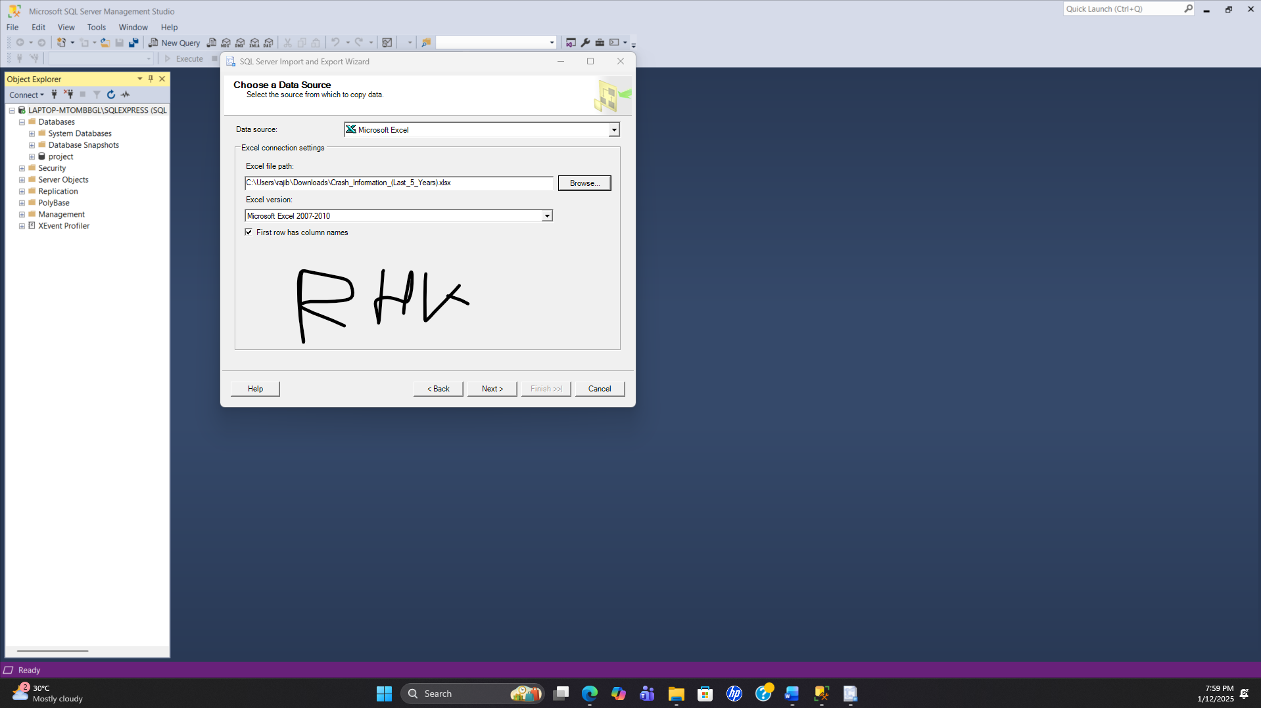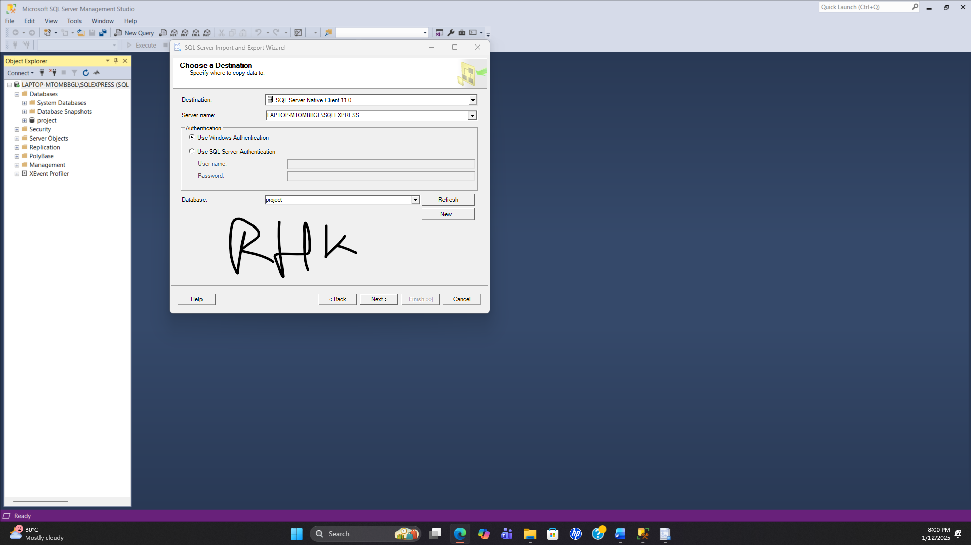

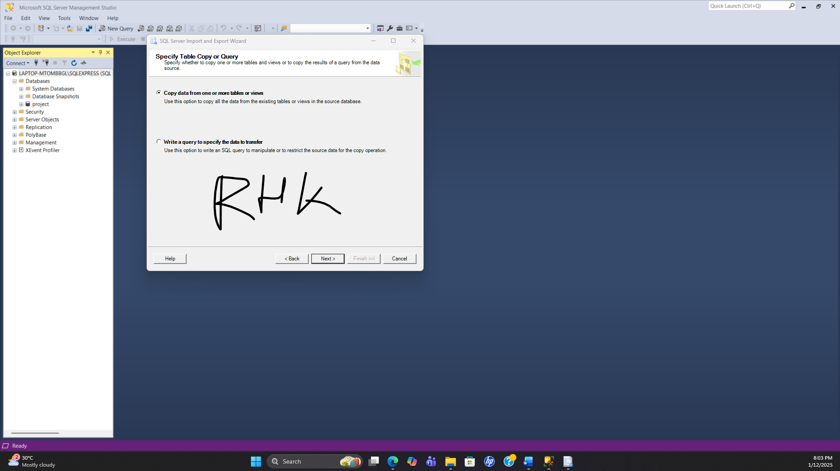

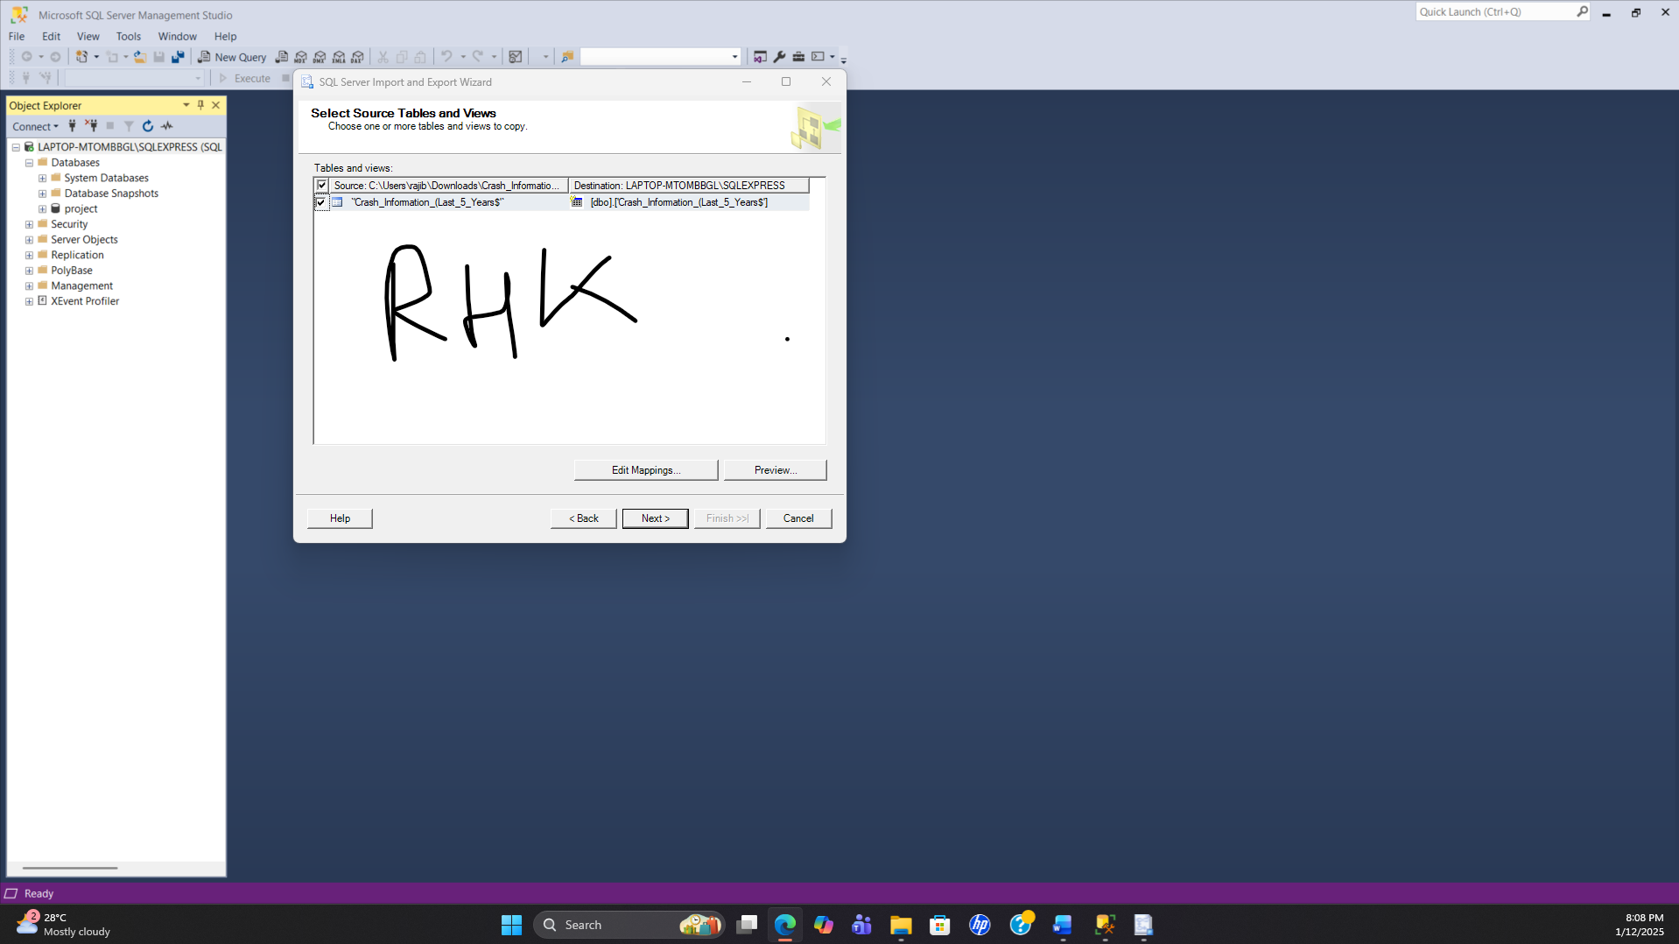

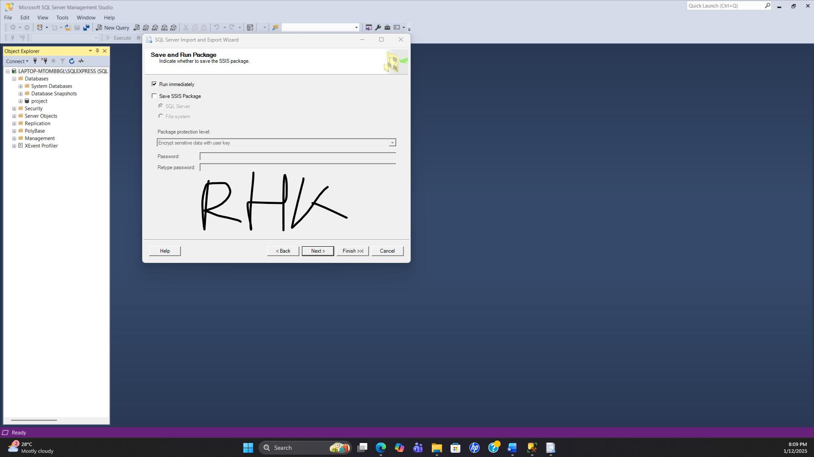

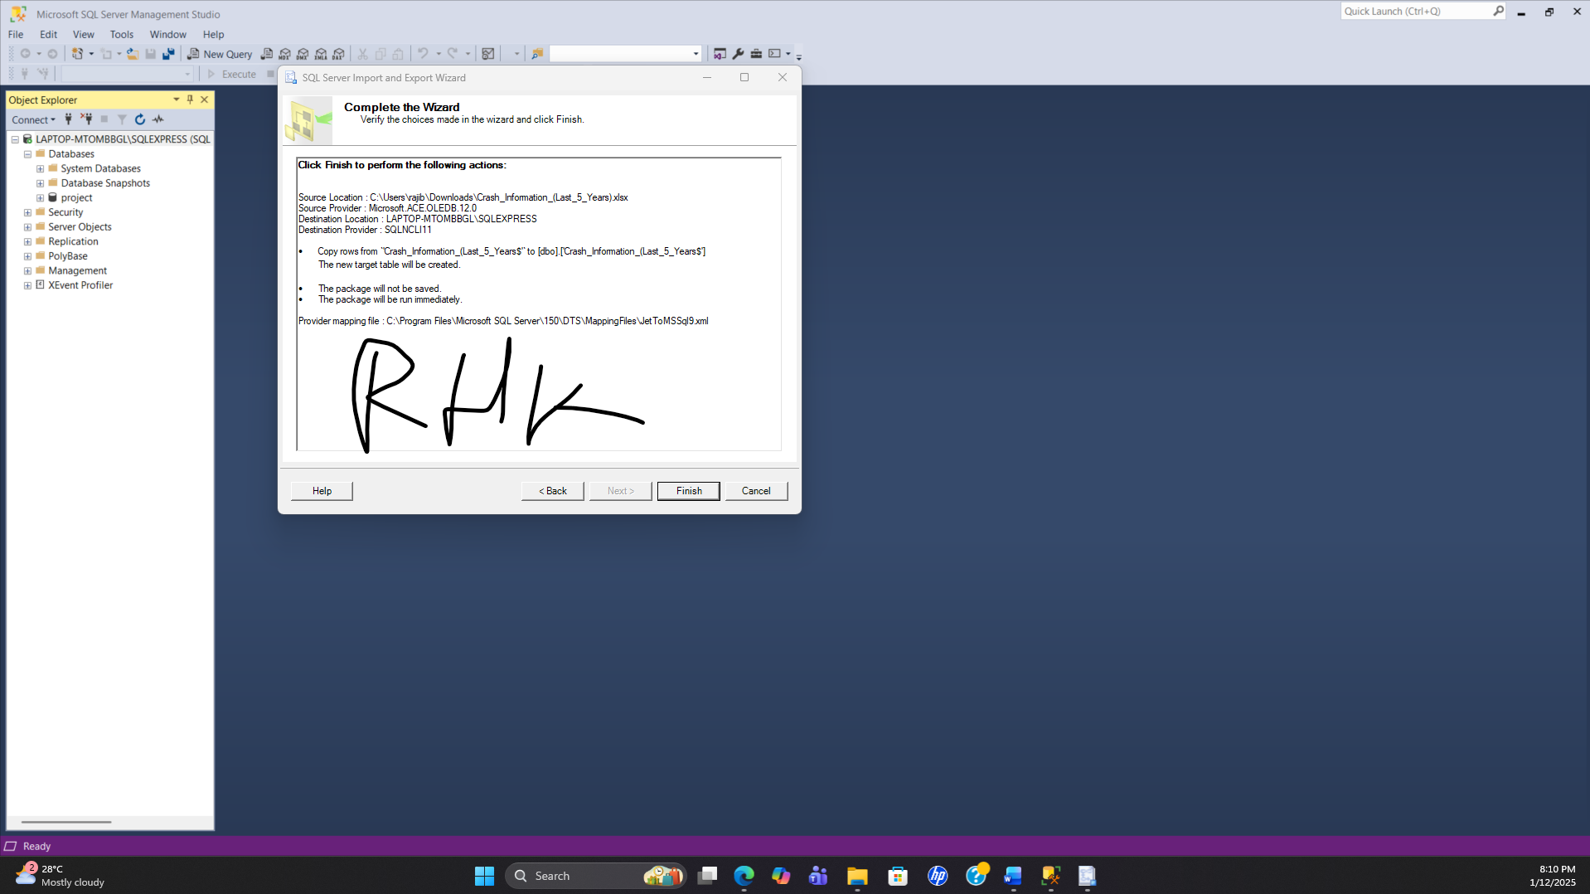

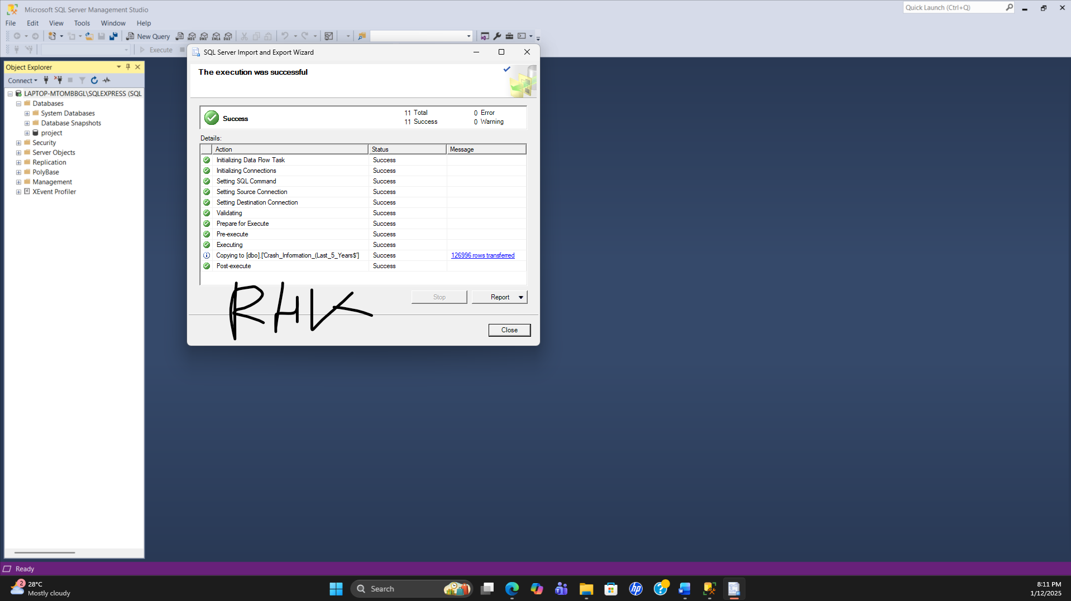

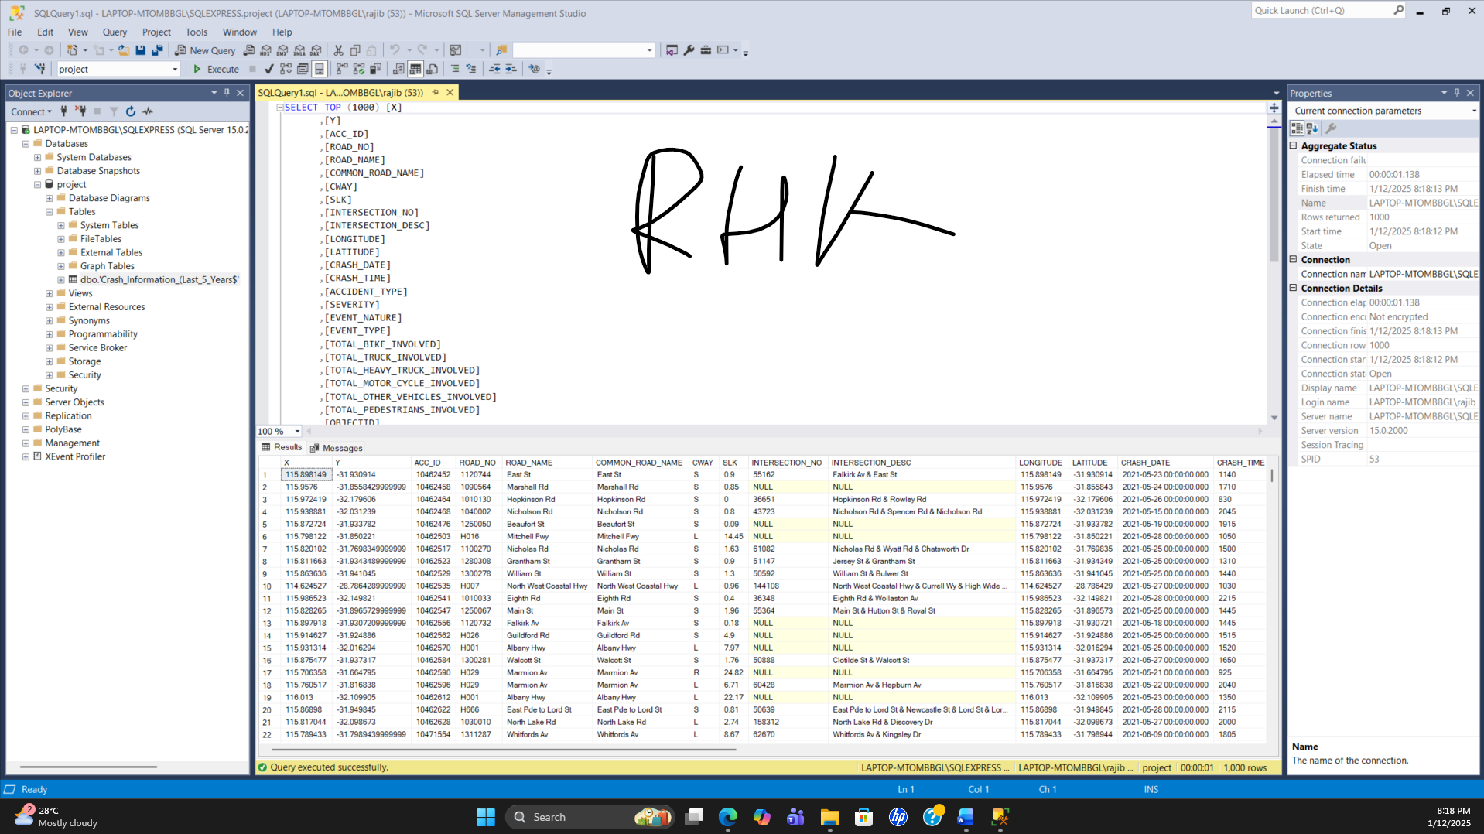

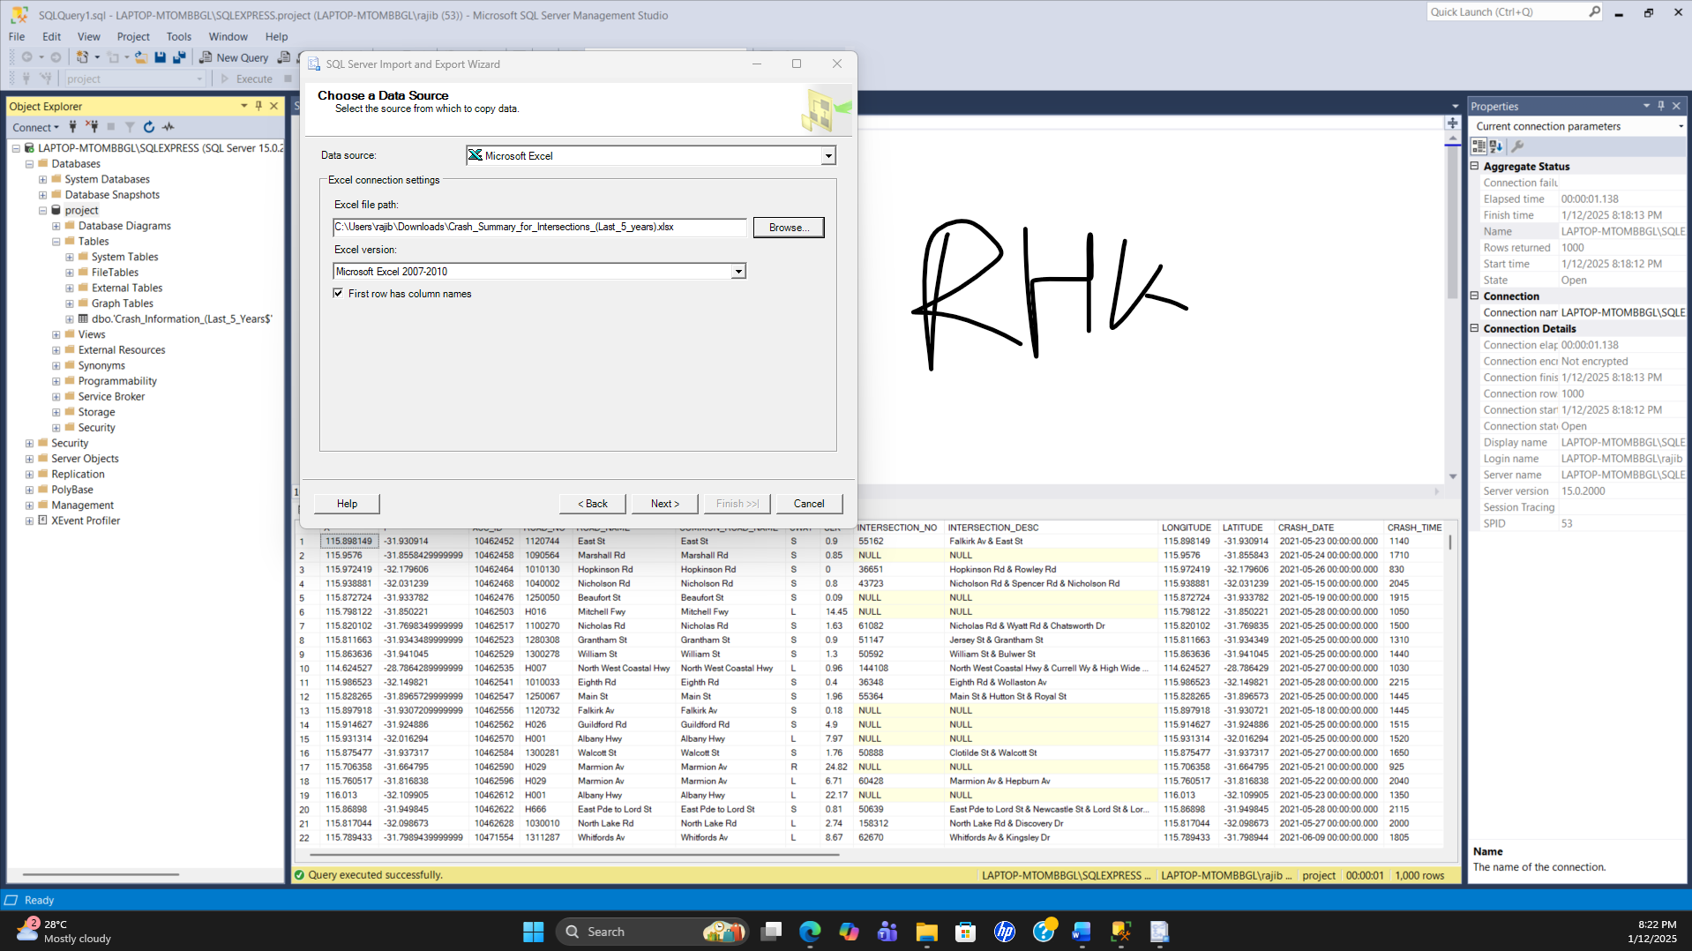

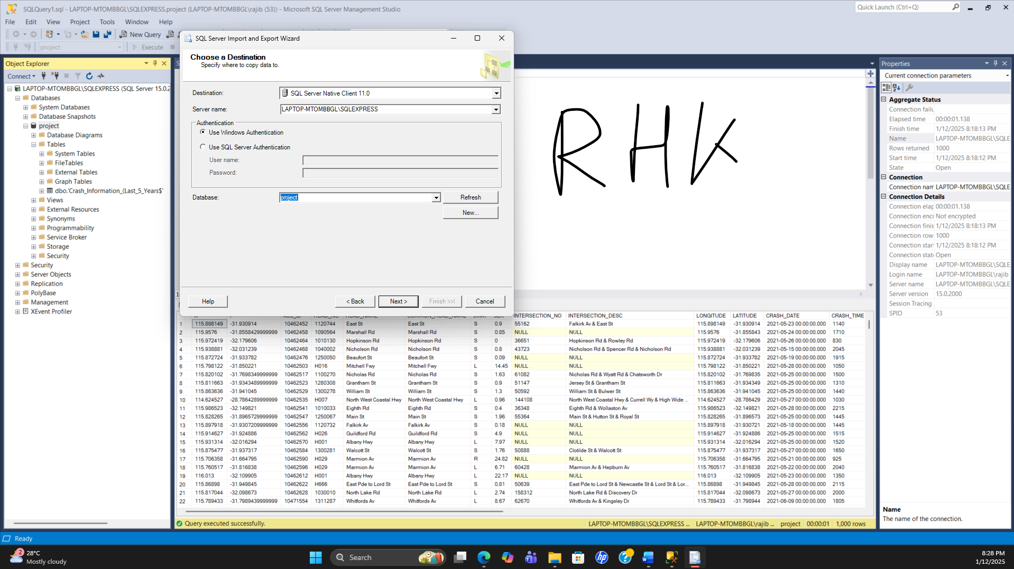

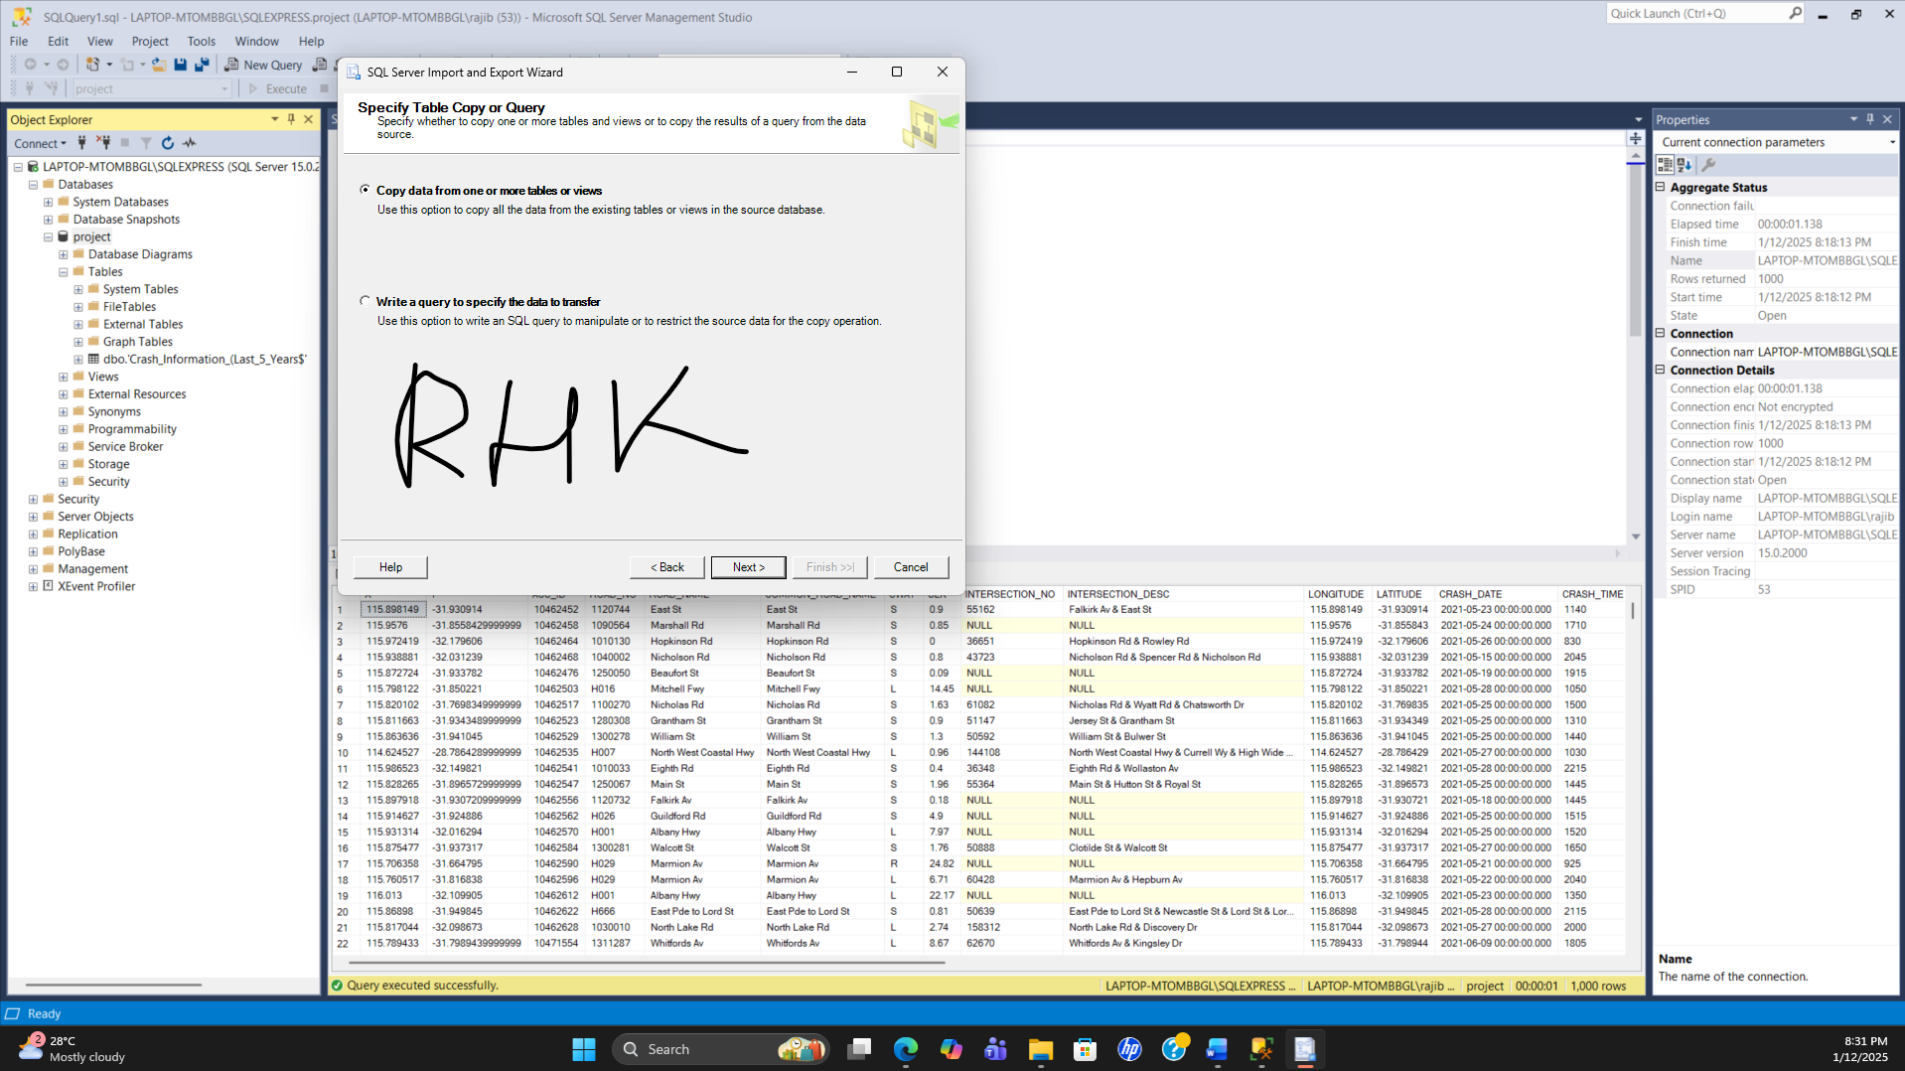

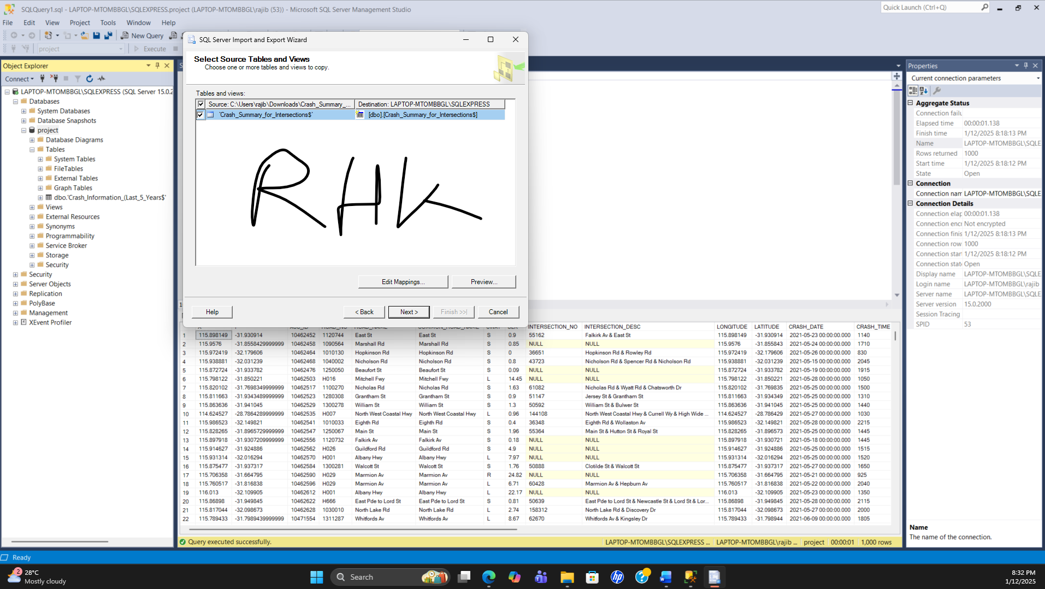

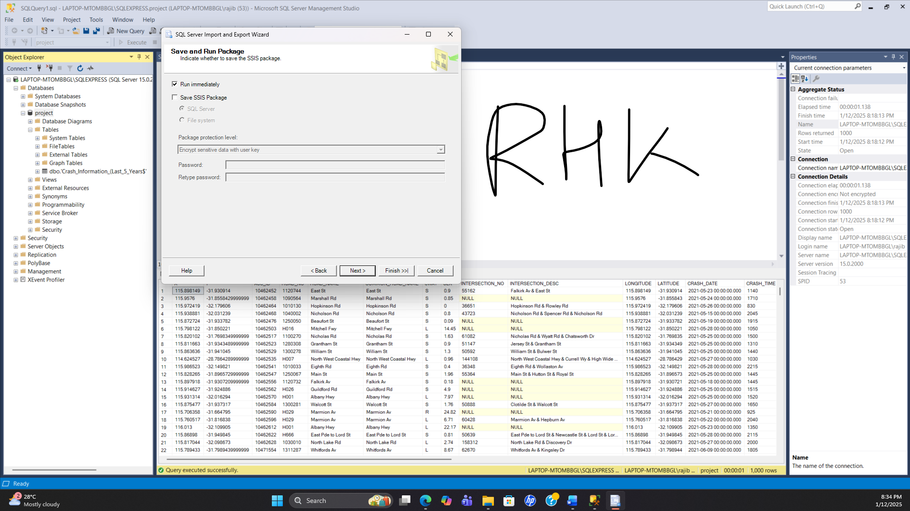

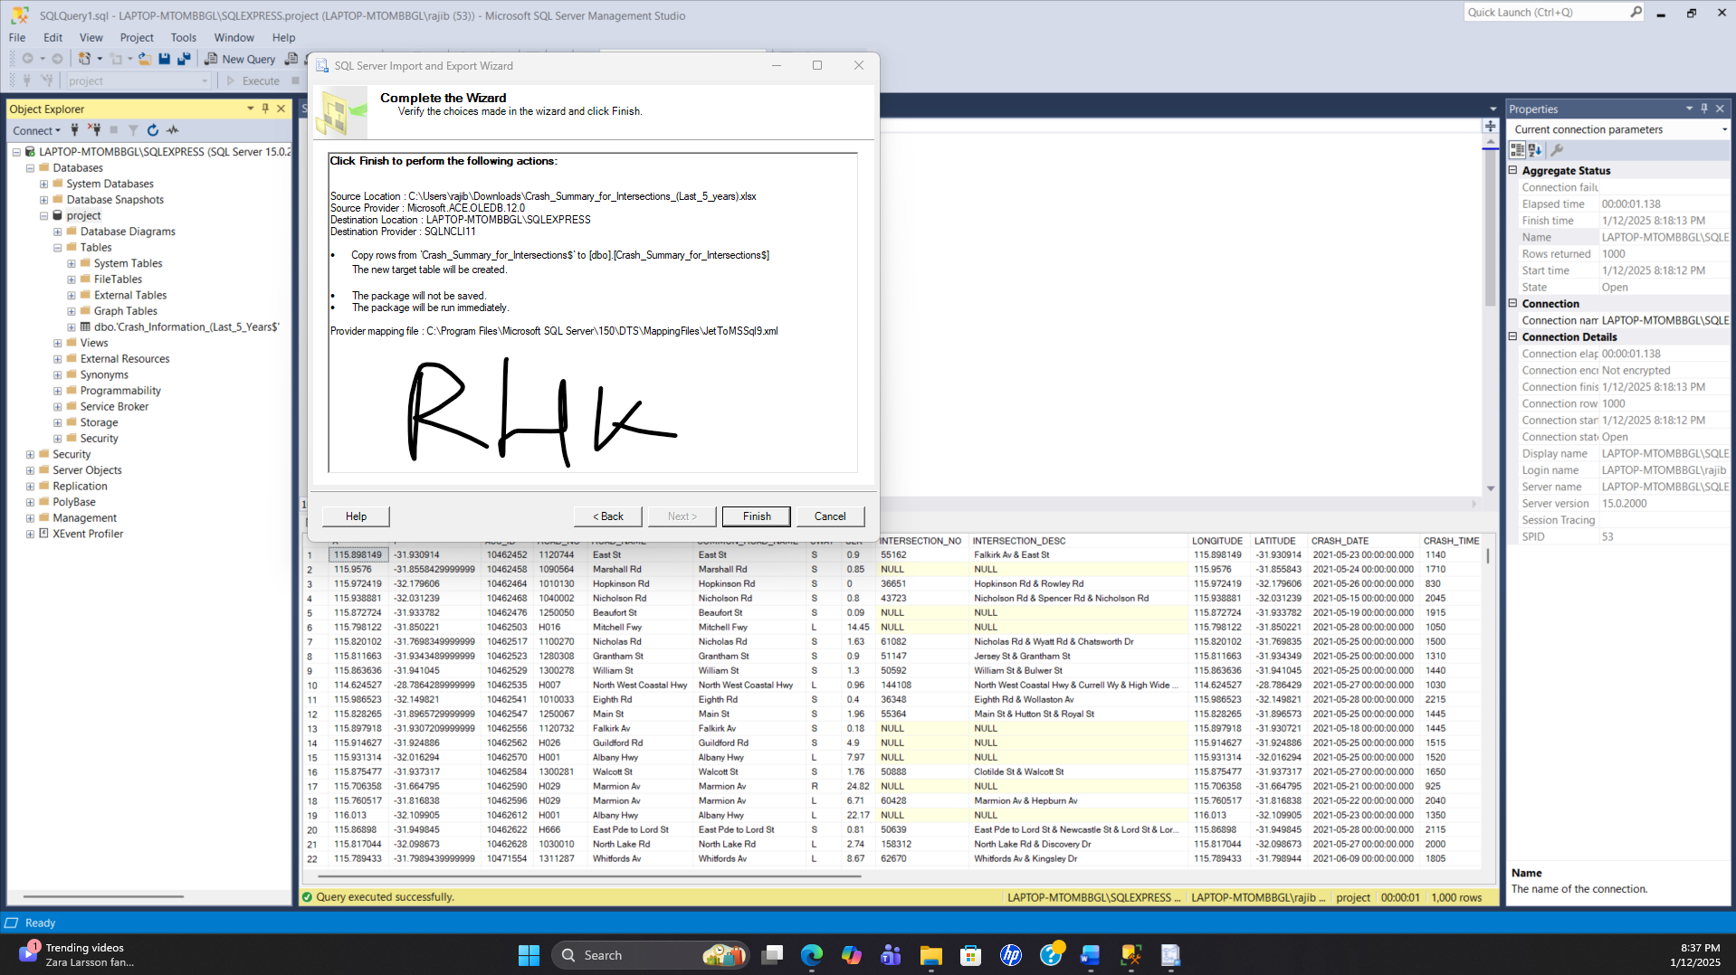

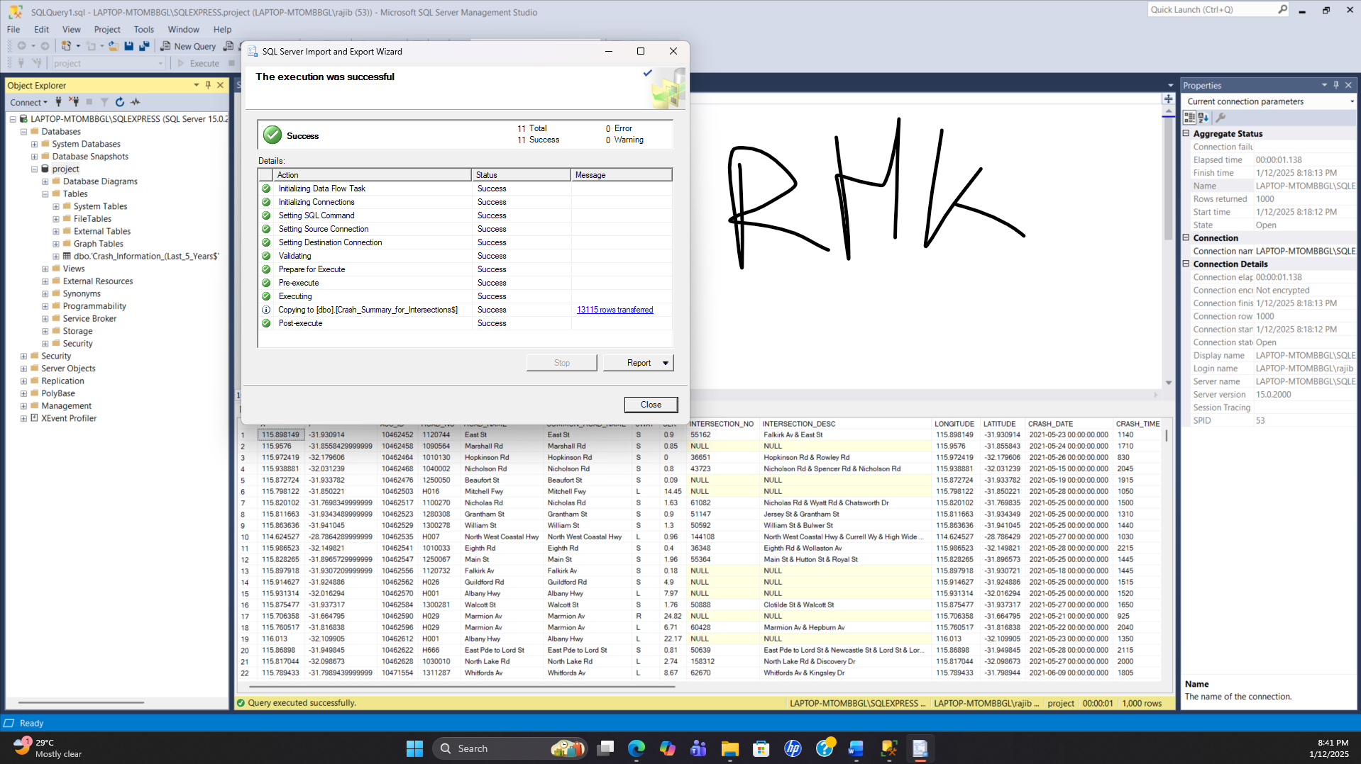

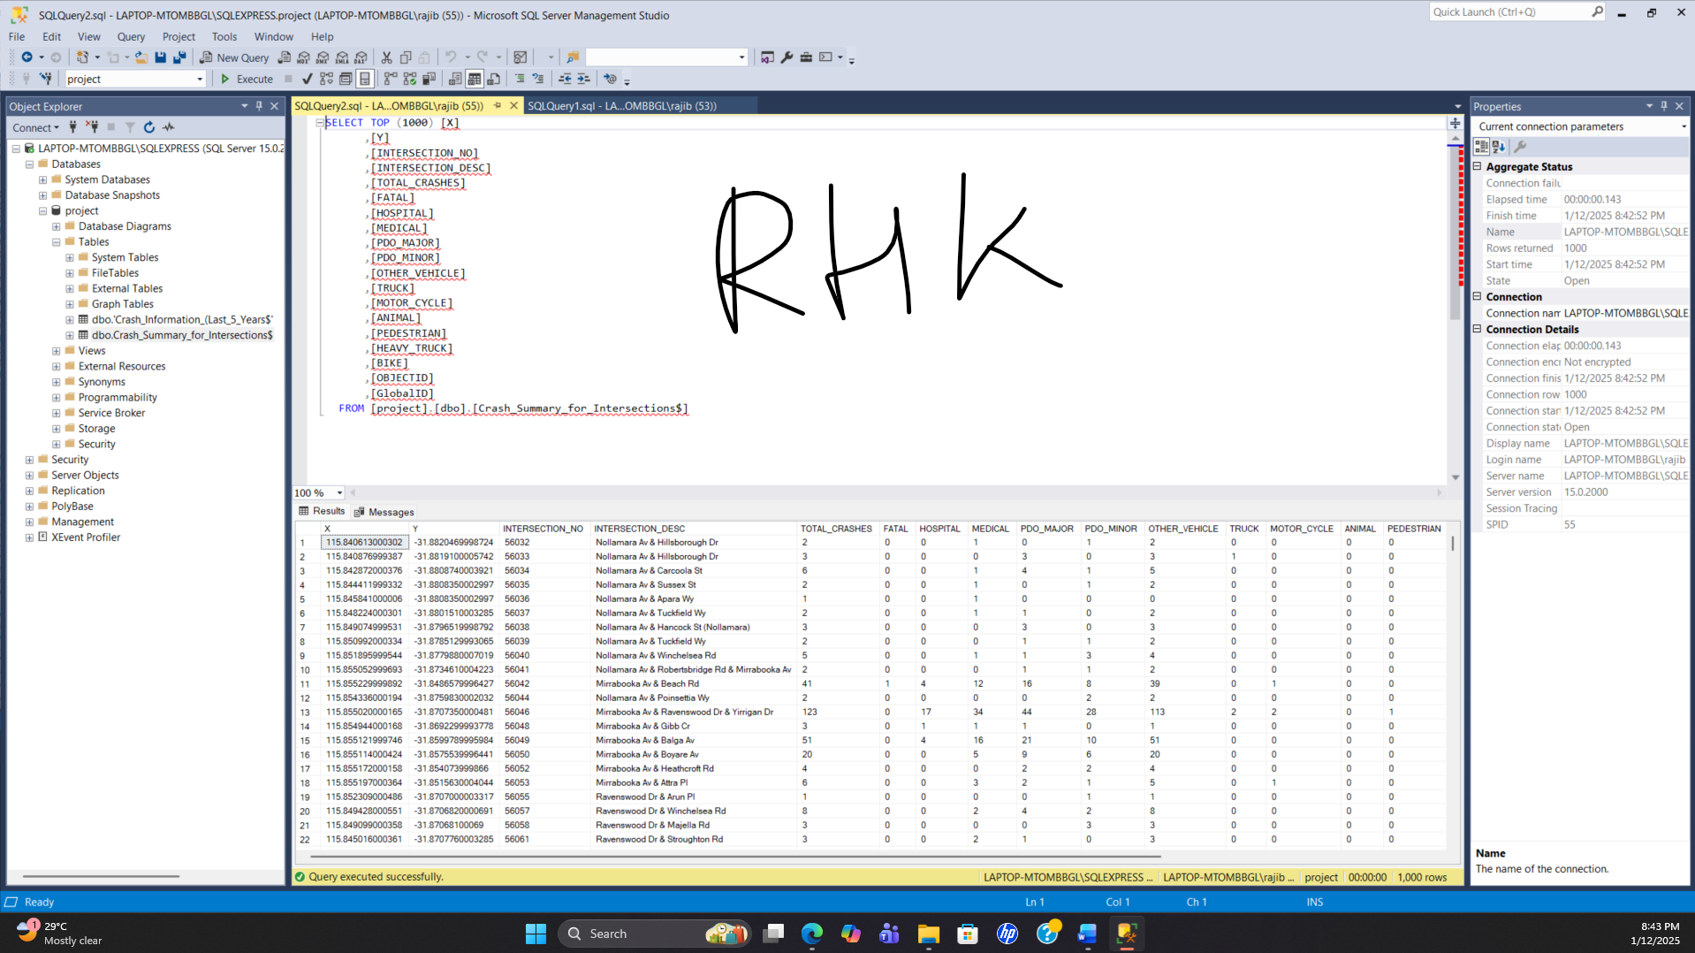

1. **Clean the data set.**   
   For the columns you highlighted, demonstrate that you have cleaned the data sets or that the data sets are clean by checking for the following (in SQL, Power BI, or tool of your choice). Demonstrate you have done the following:

* Categorical fields are consistently named.
* Values use the same unit.
* Values have a single type (no mix of strings and integers for example)
* Missing values are identified in a consistent way

Keep a record of any data cleaning you performed using **one** of the following

* Maintaining a text file with your sql queries
* A screenshot of Power BI transforms
* Using the log below if making changes in xlsx

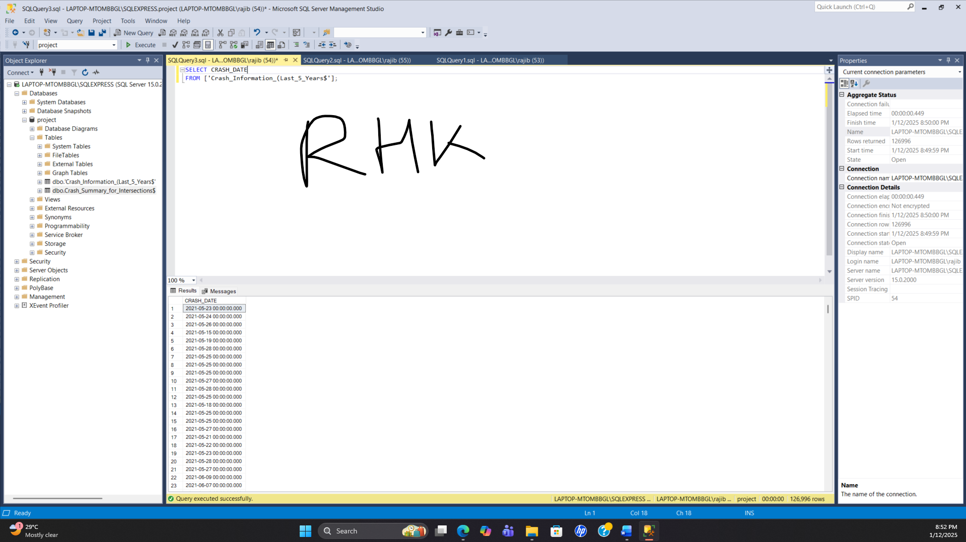

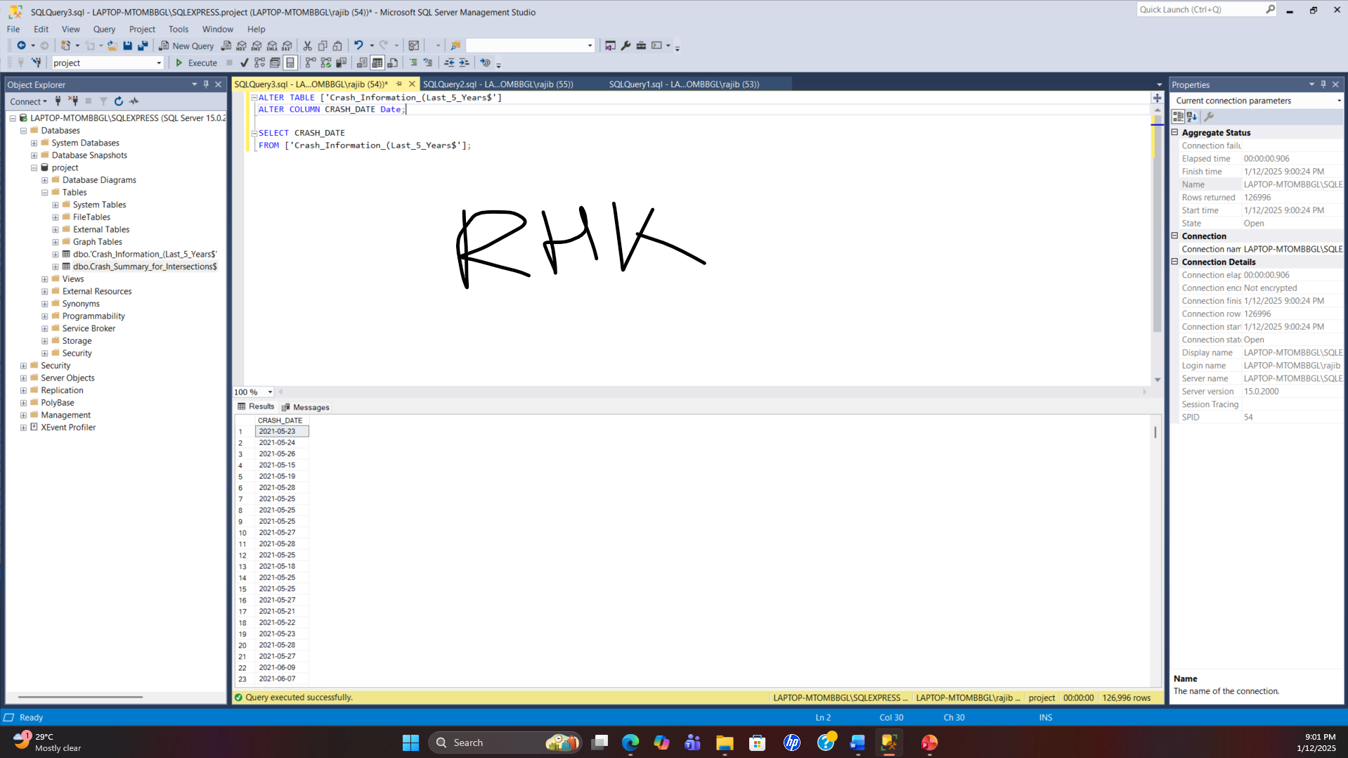

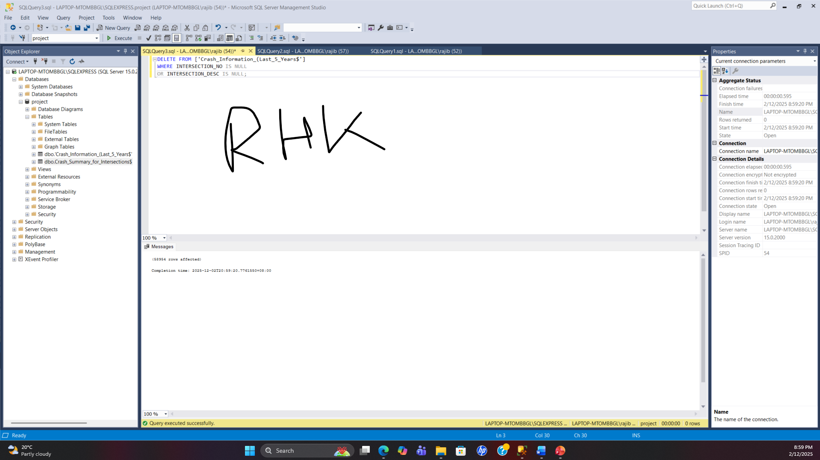

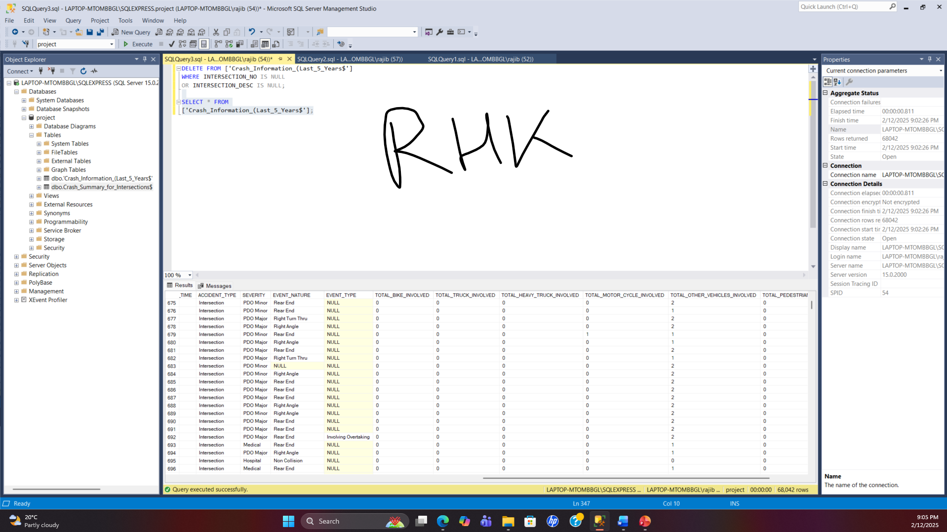

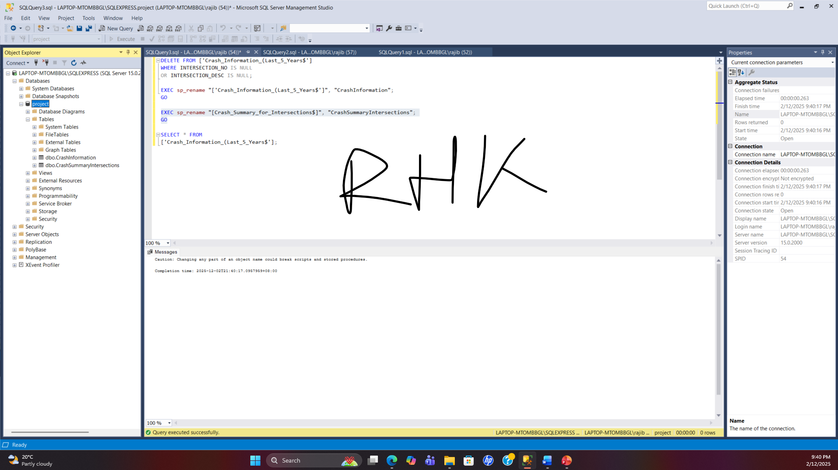

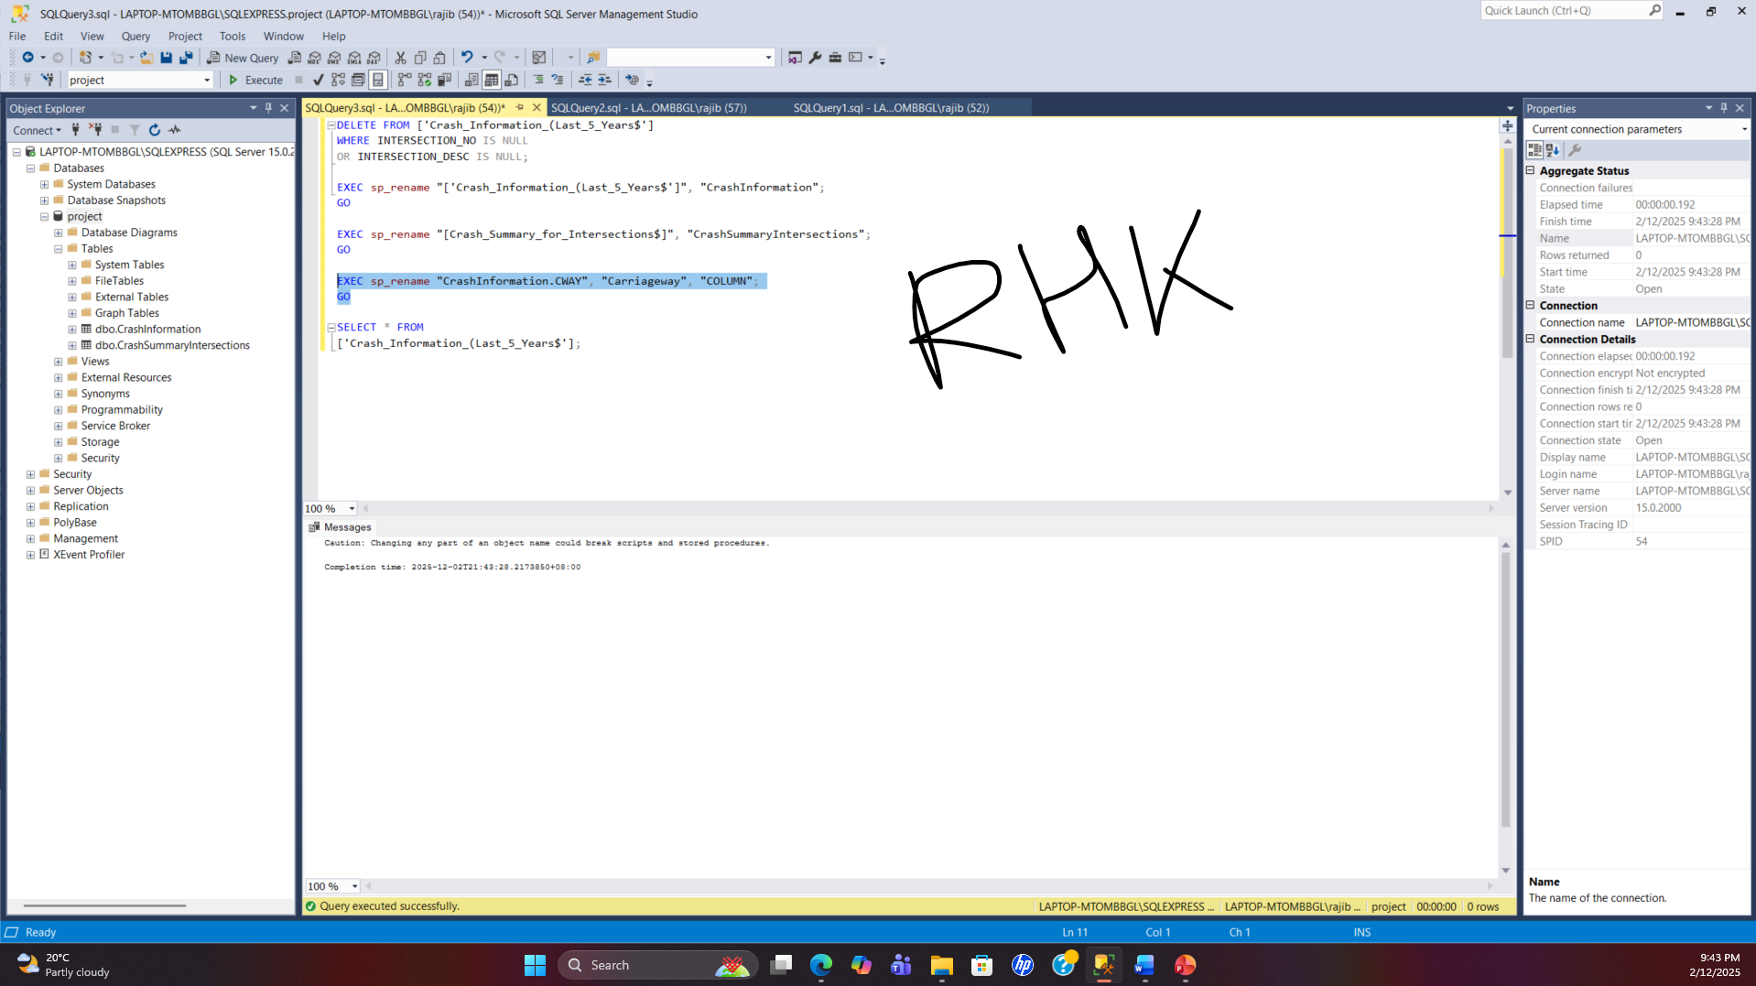

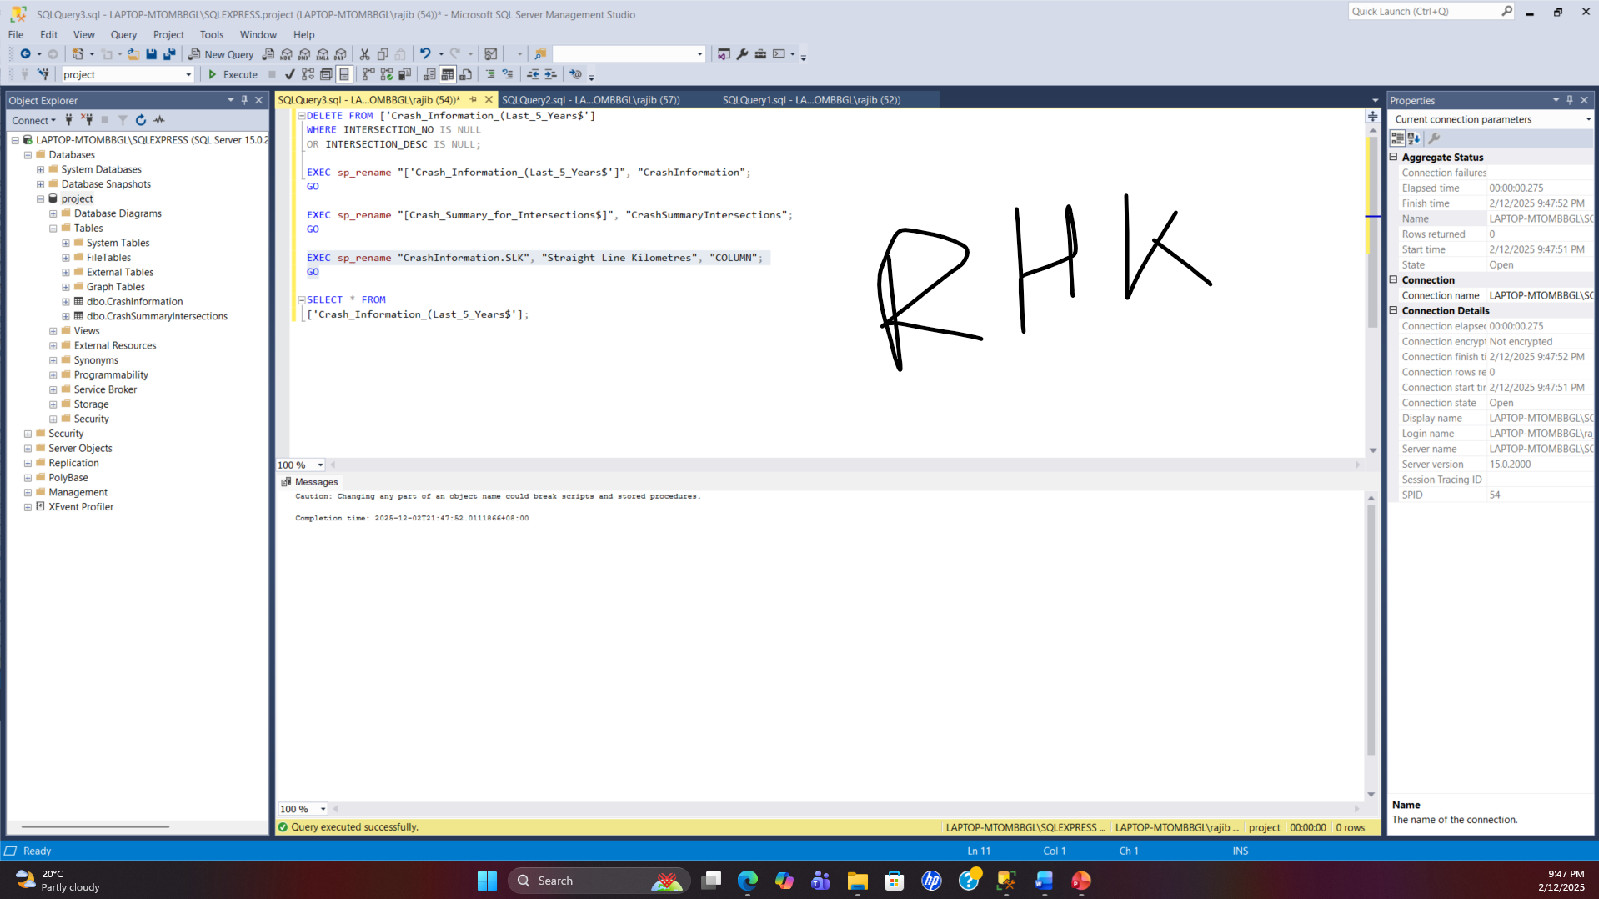

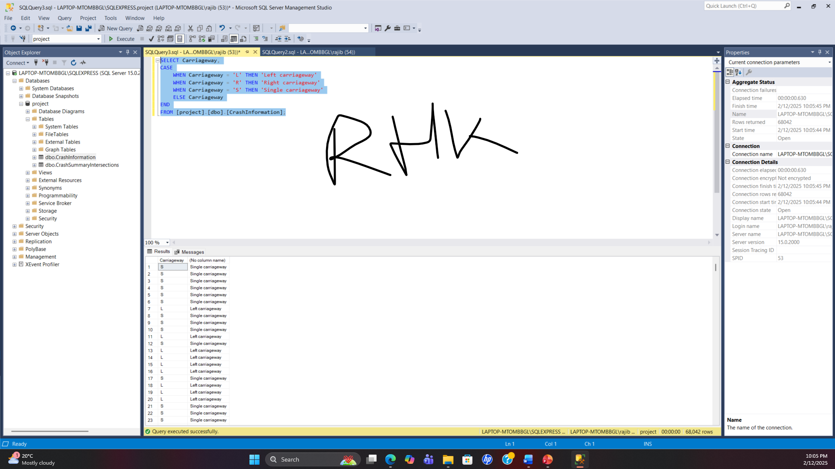

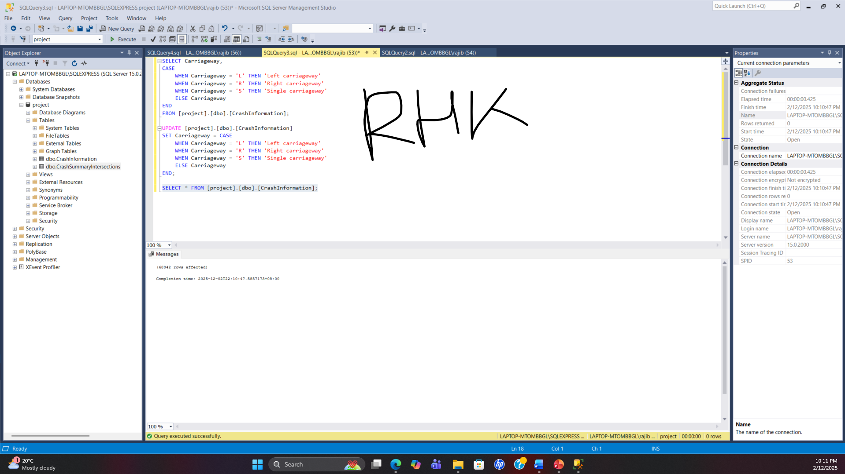

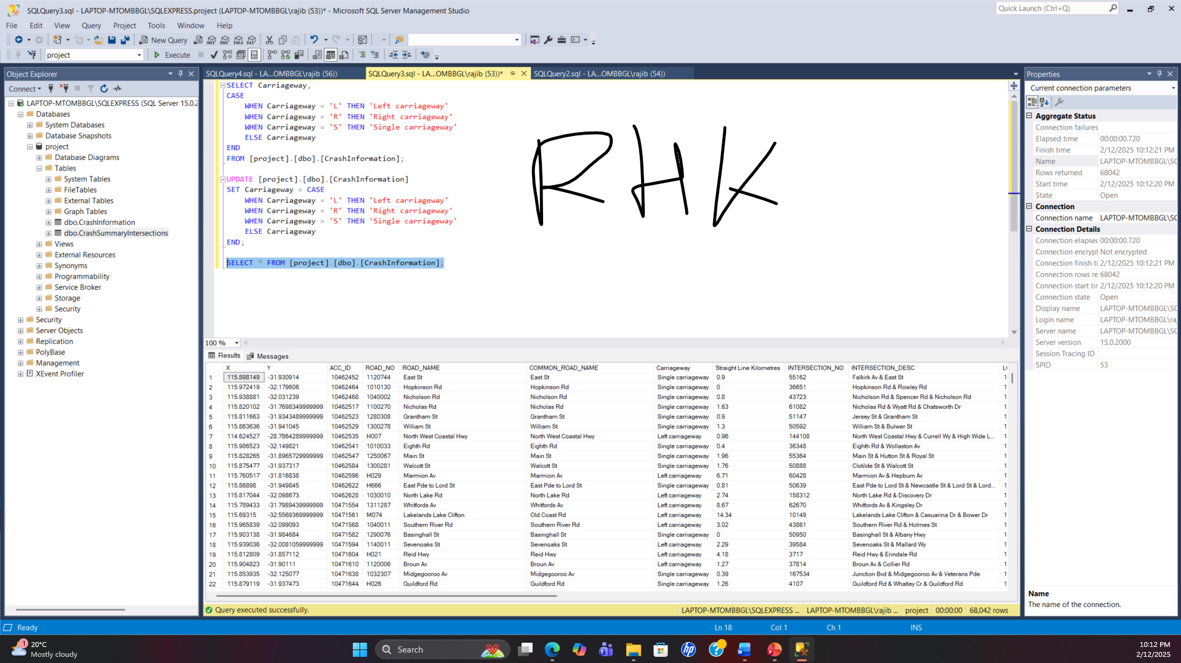

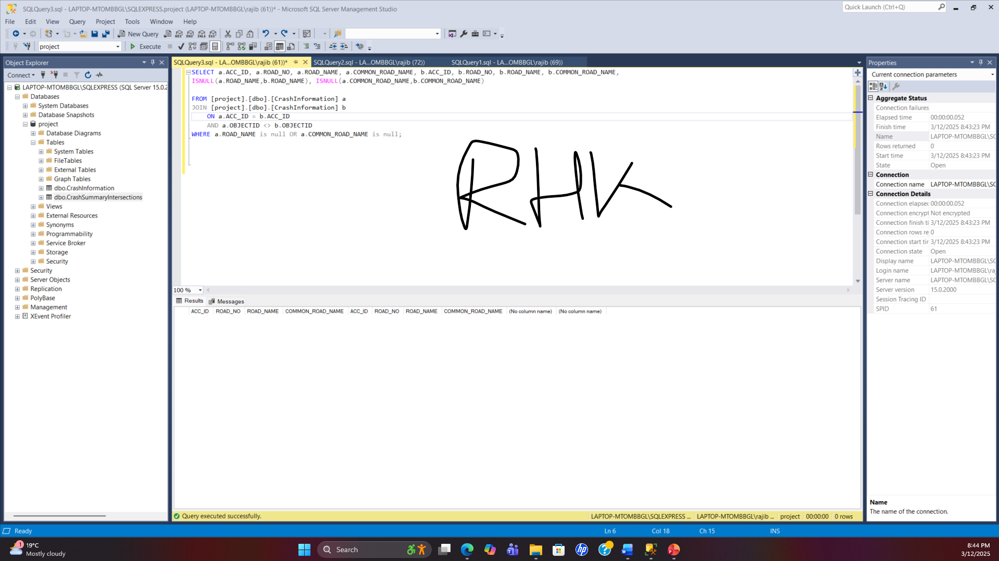

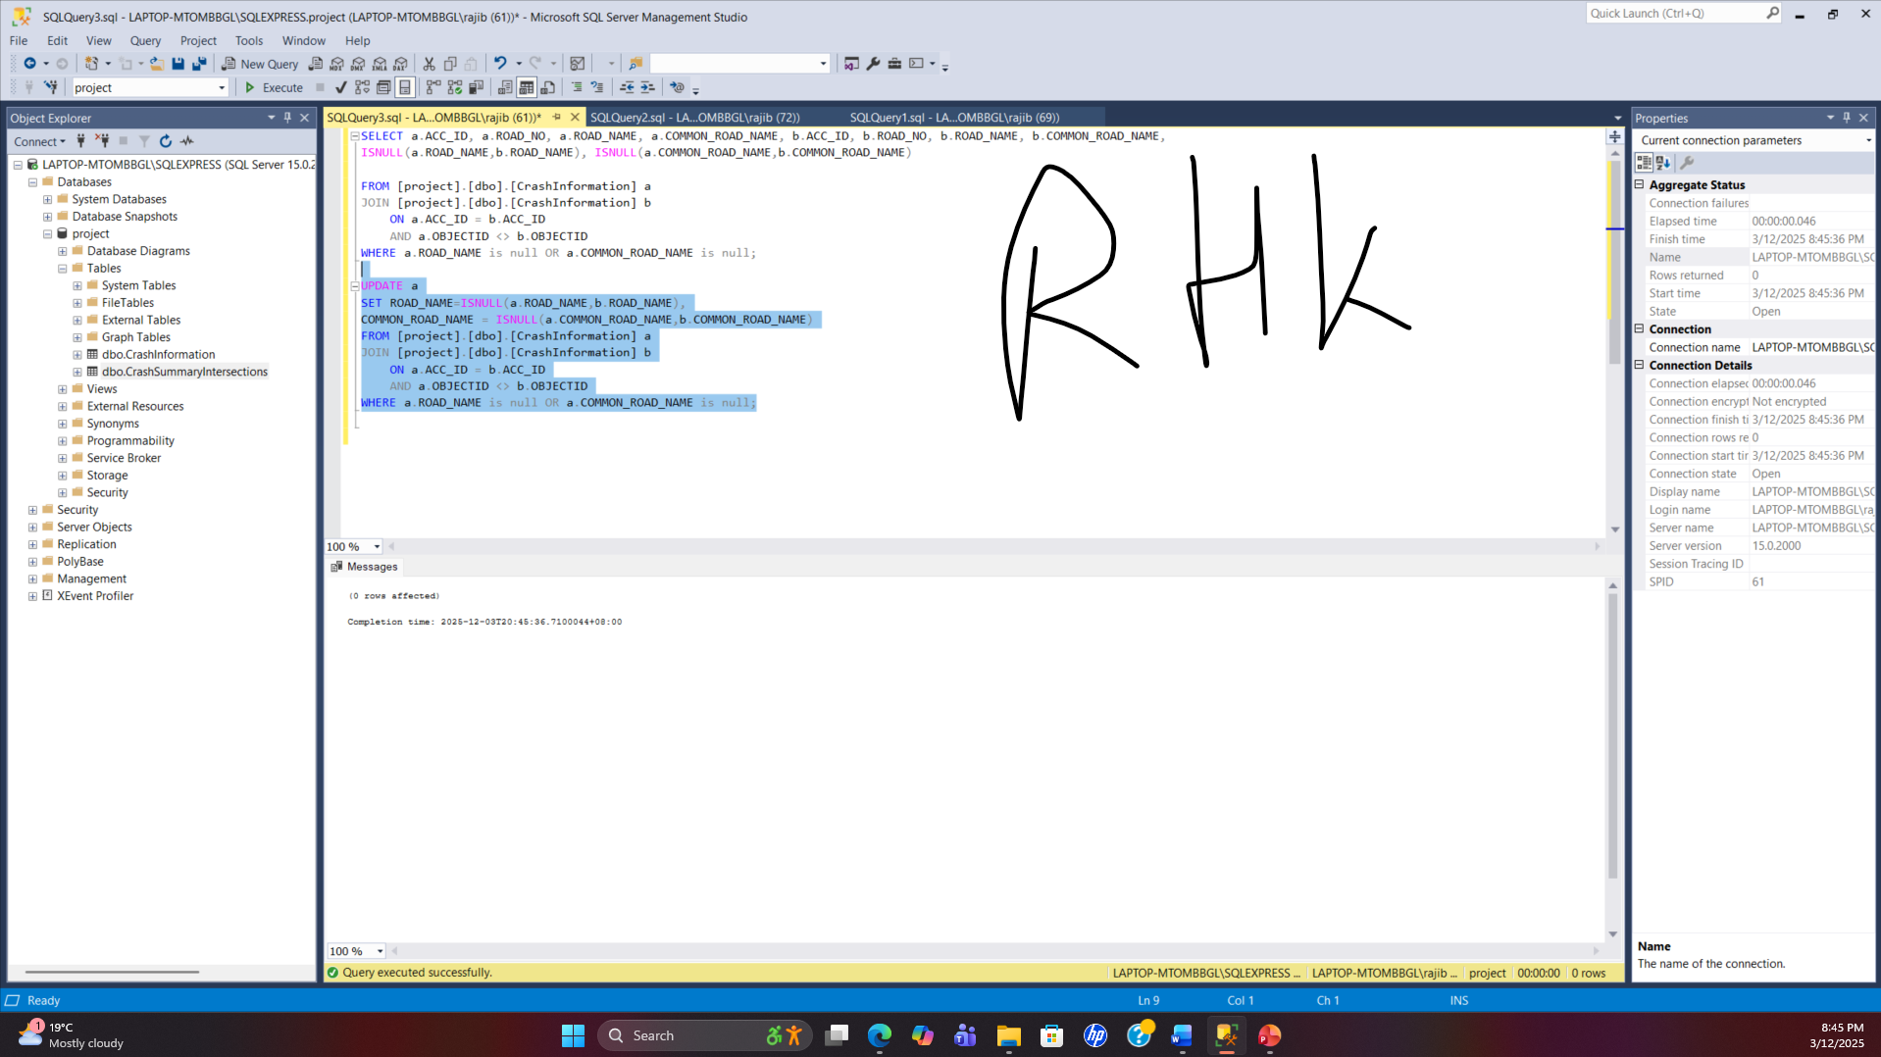

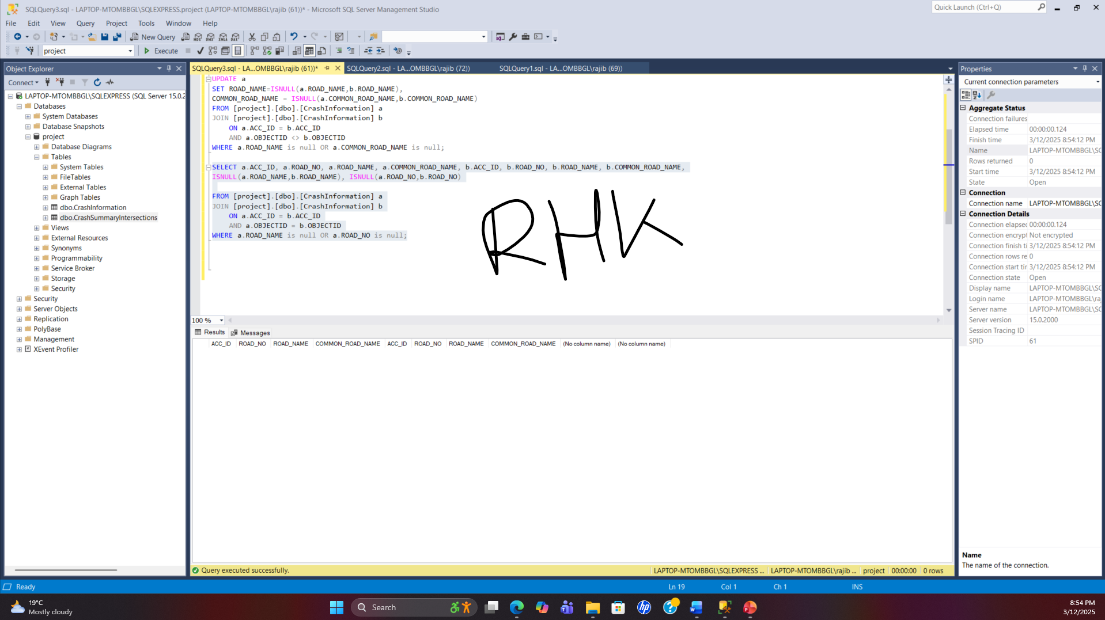

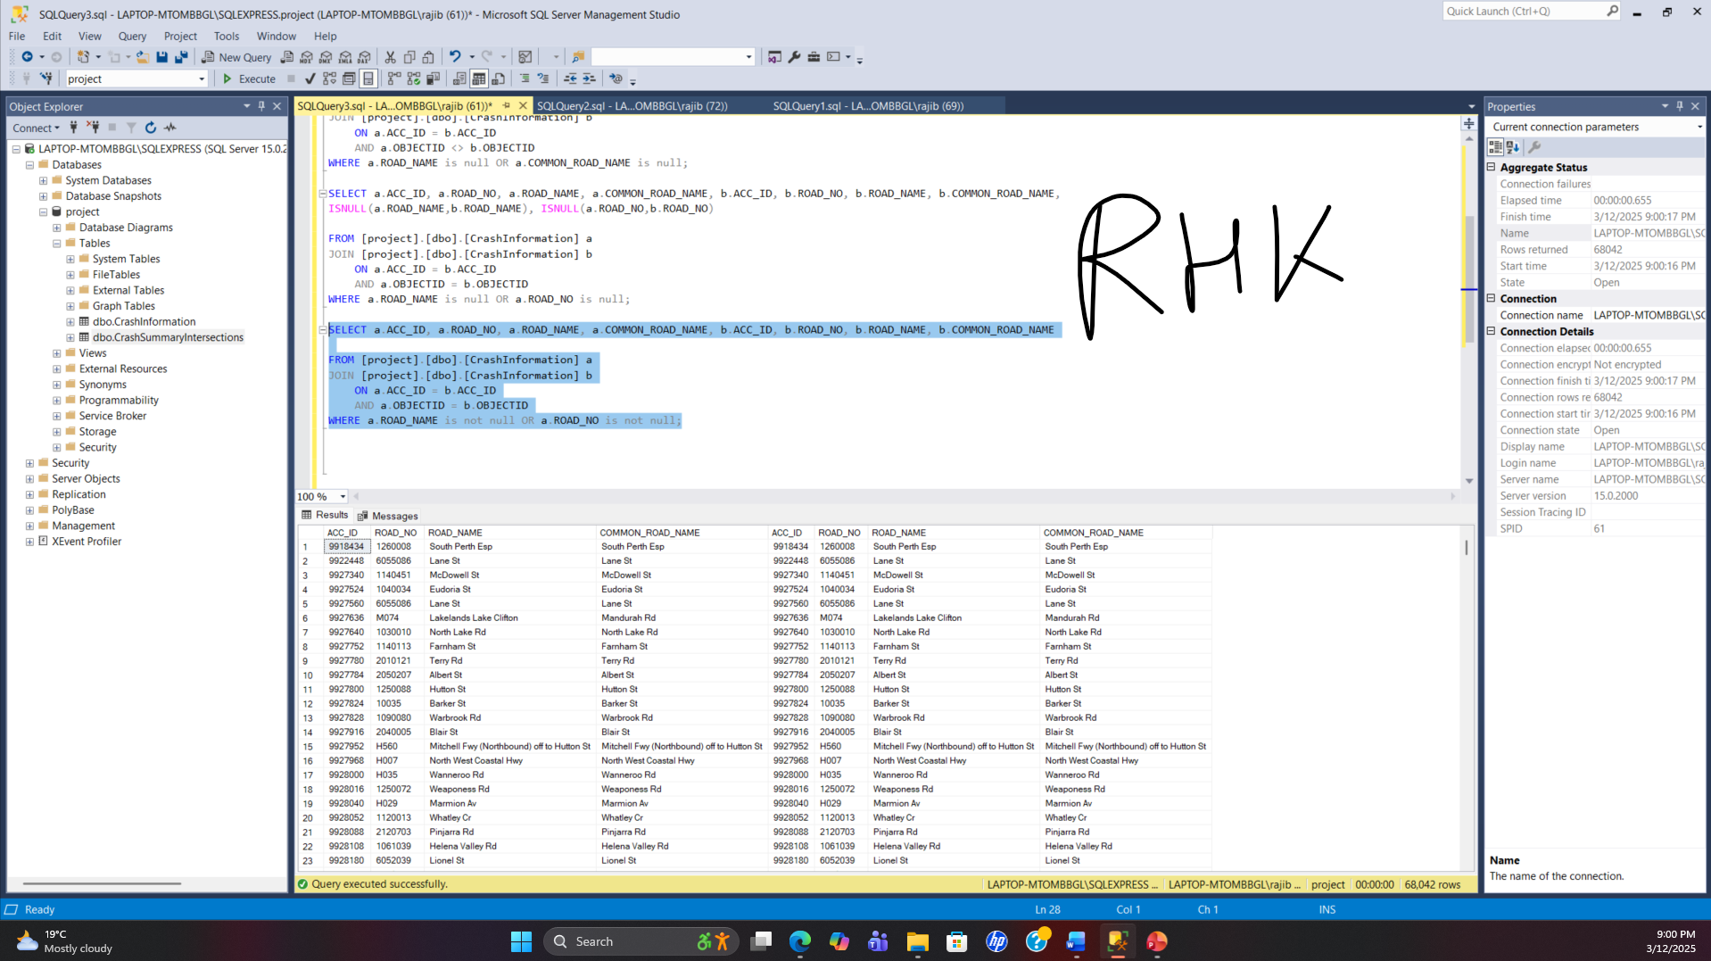

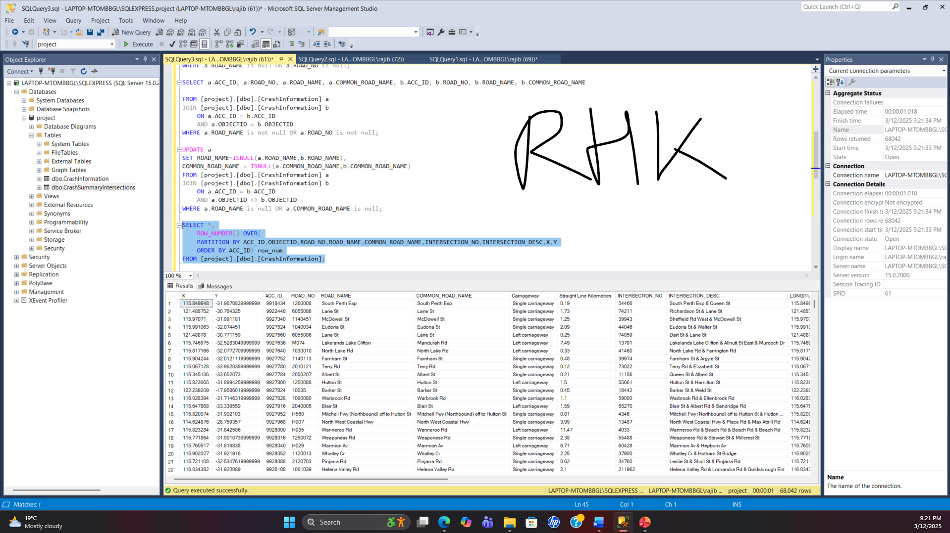

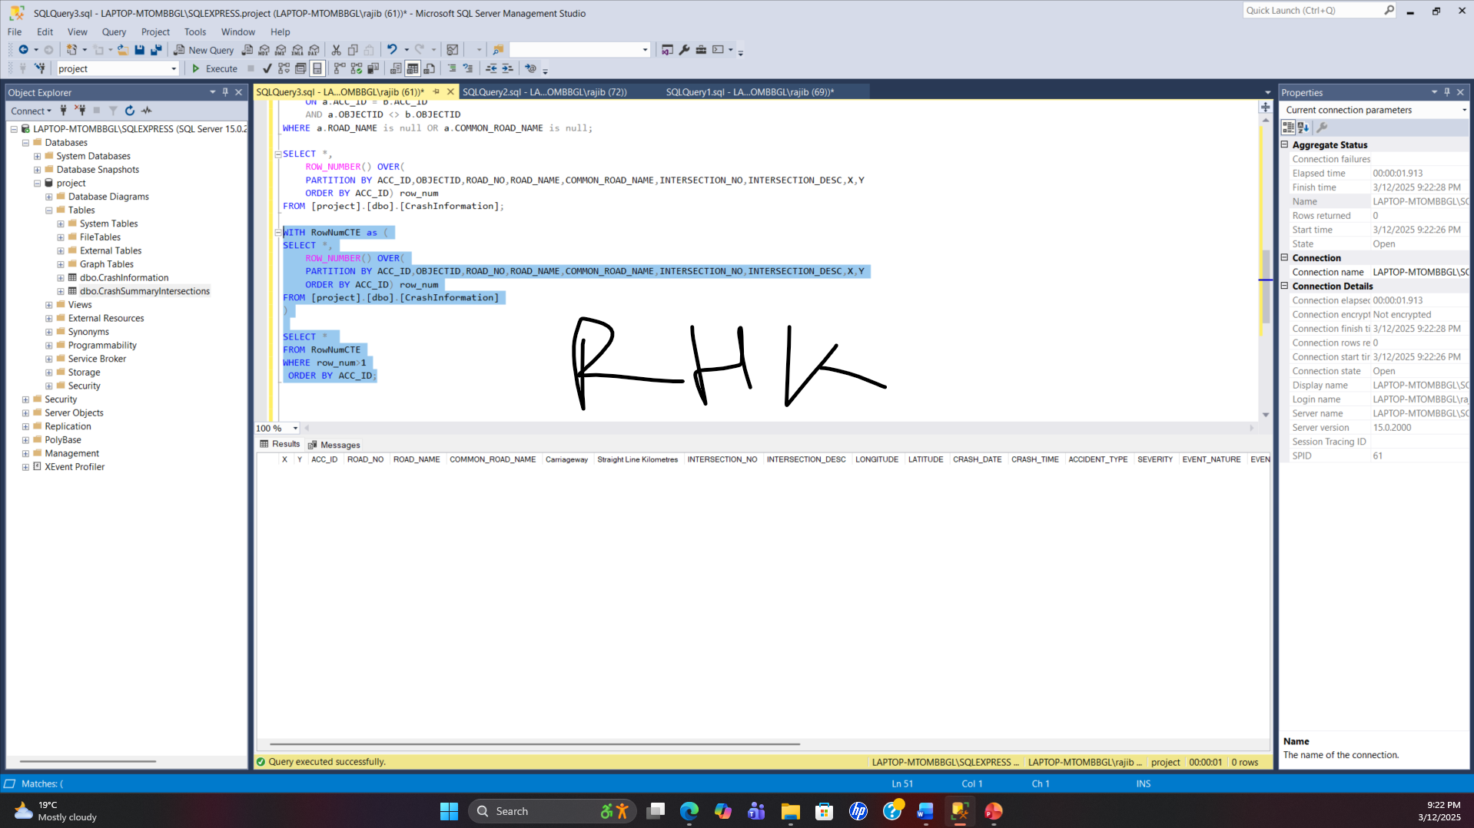

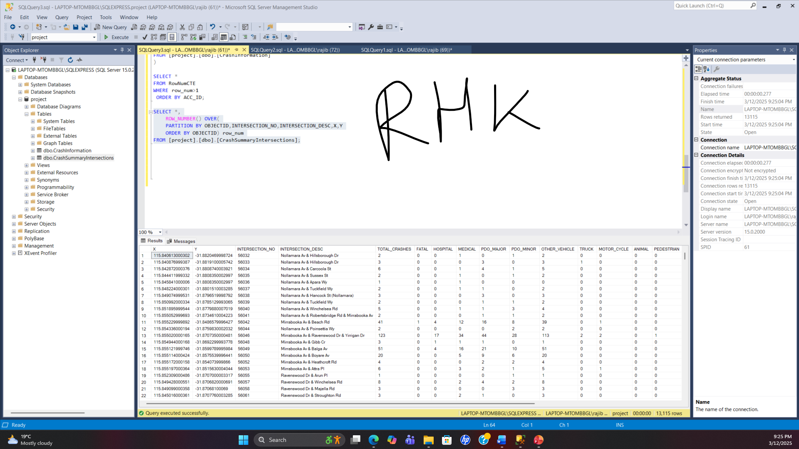

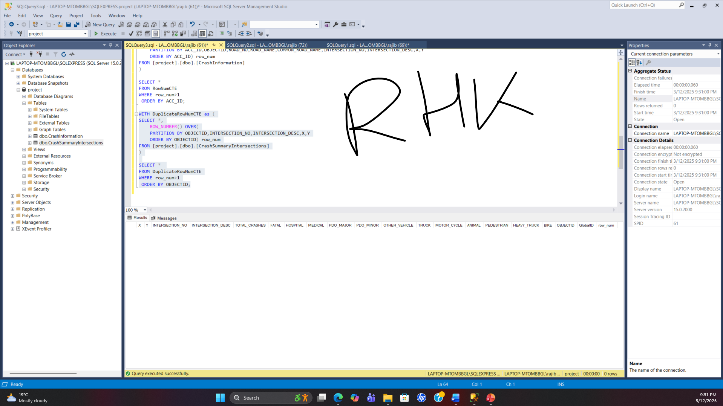

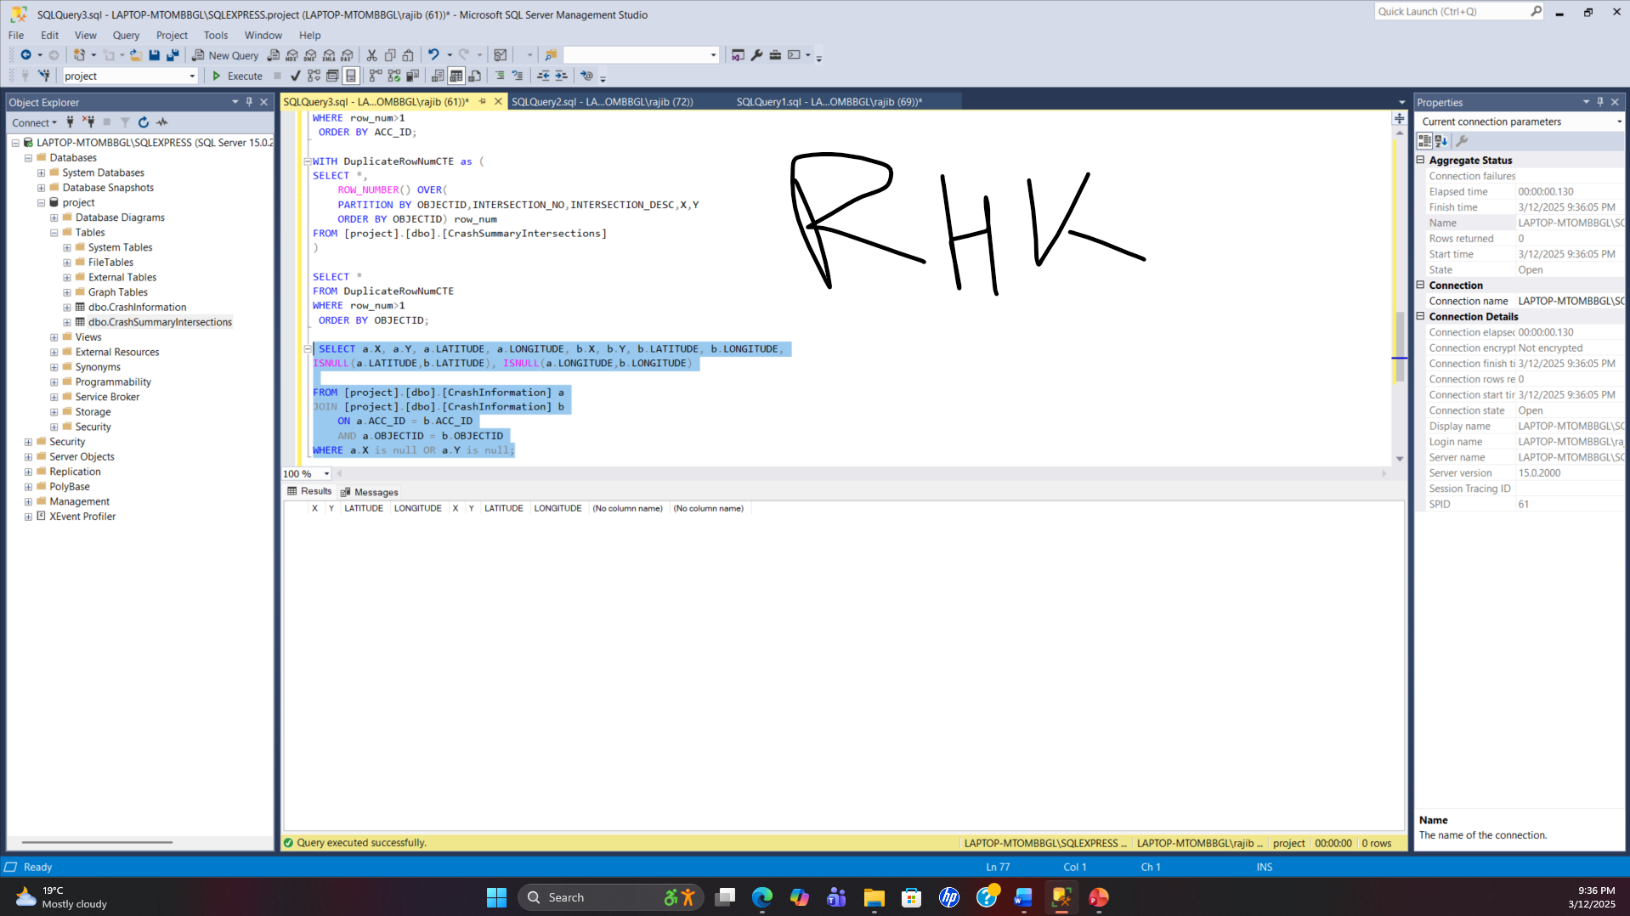

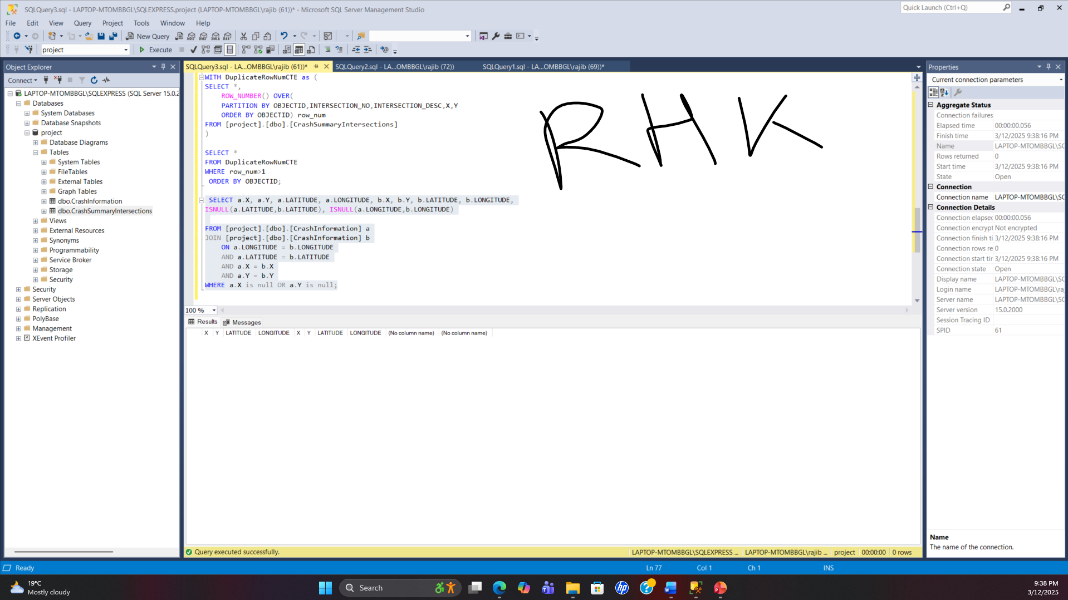

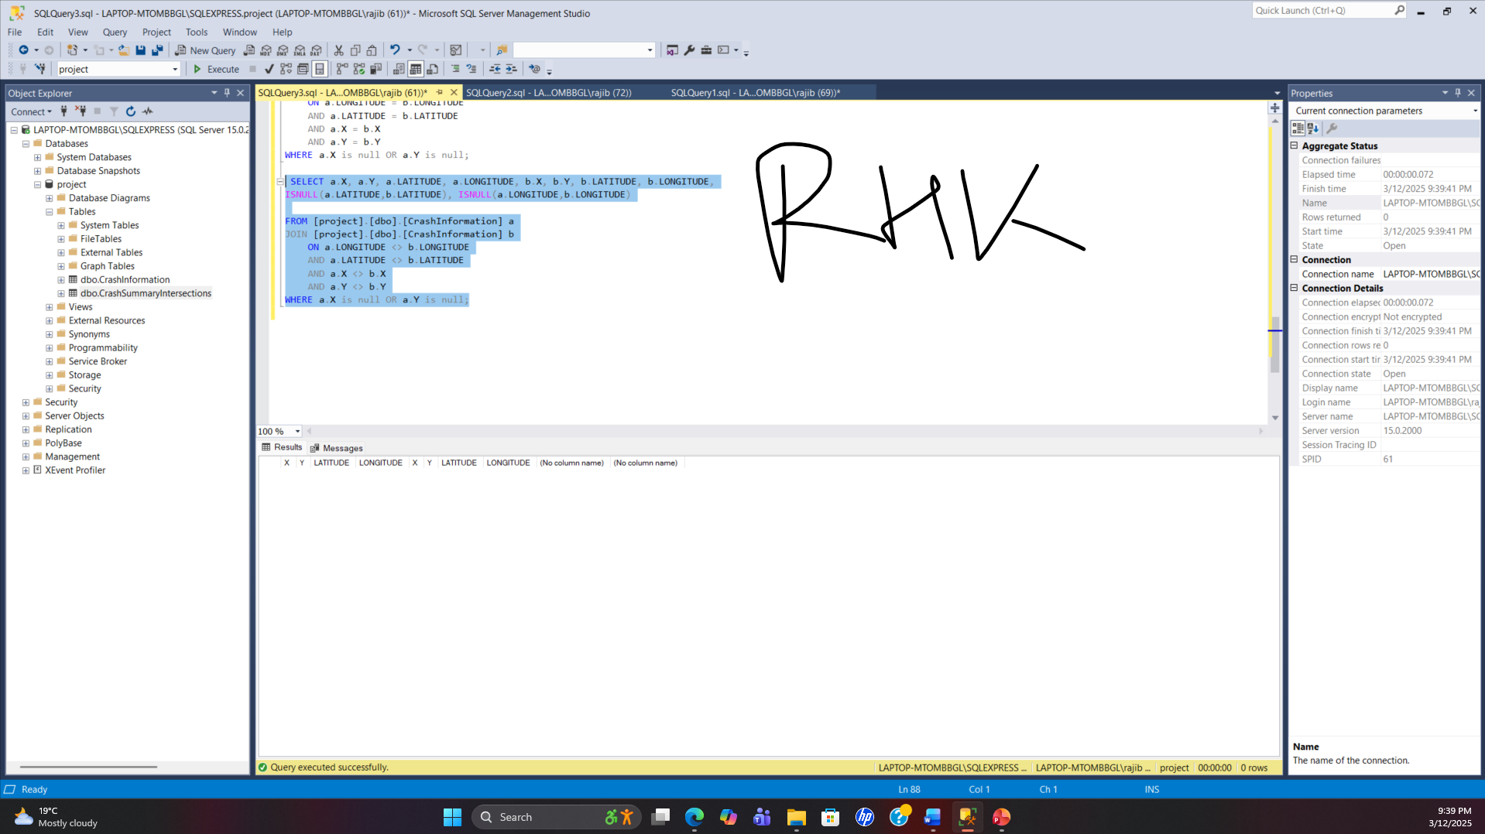

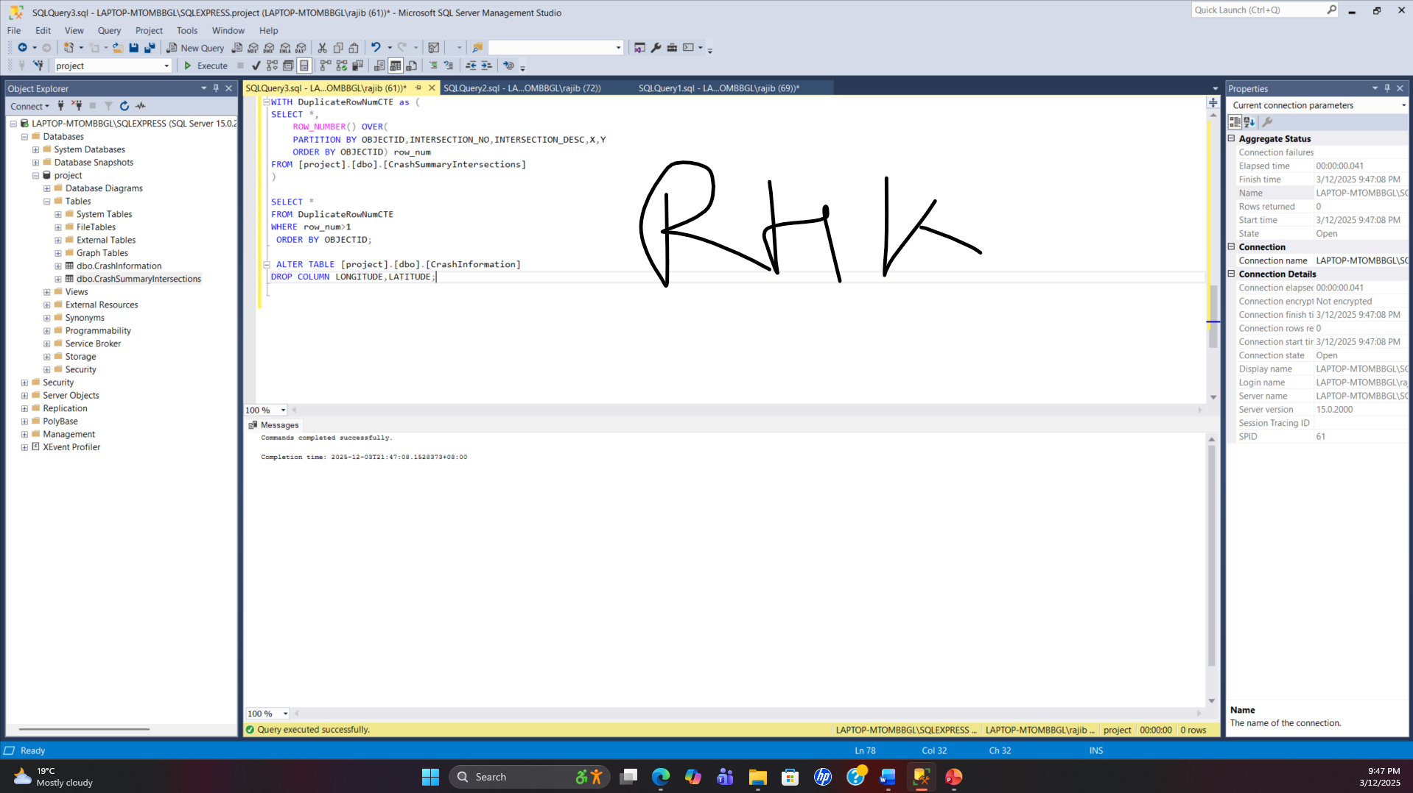

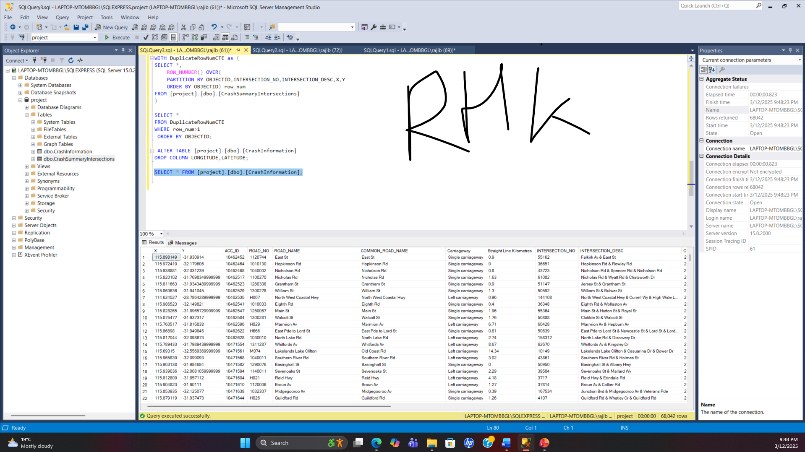

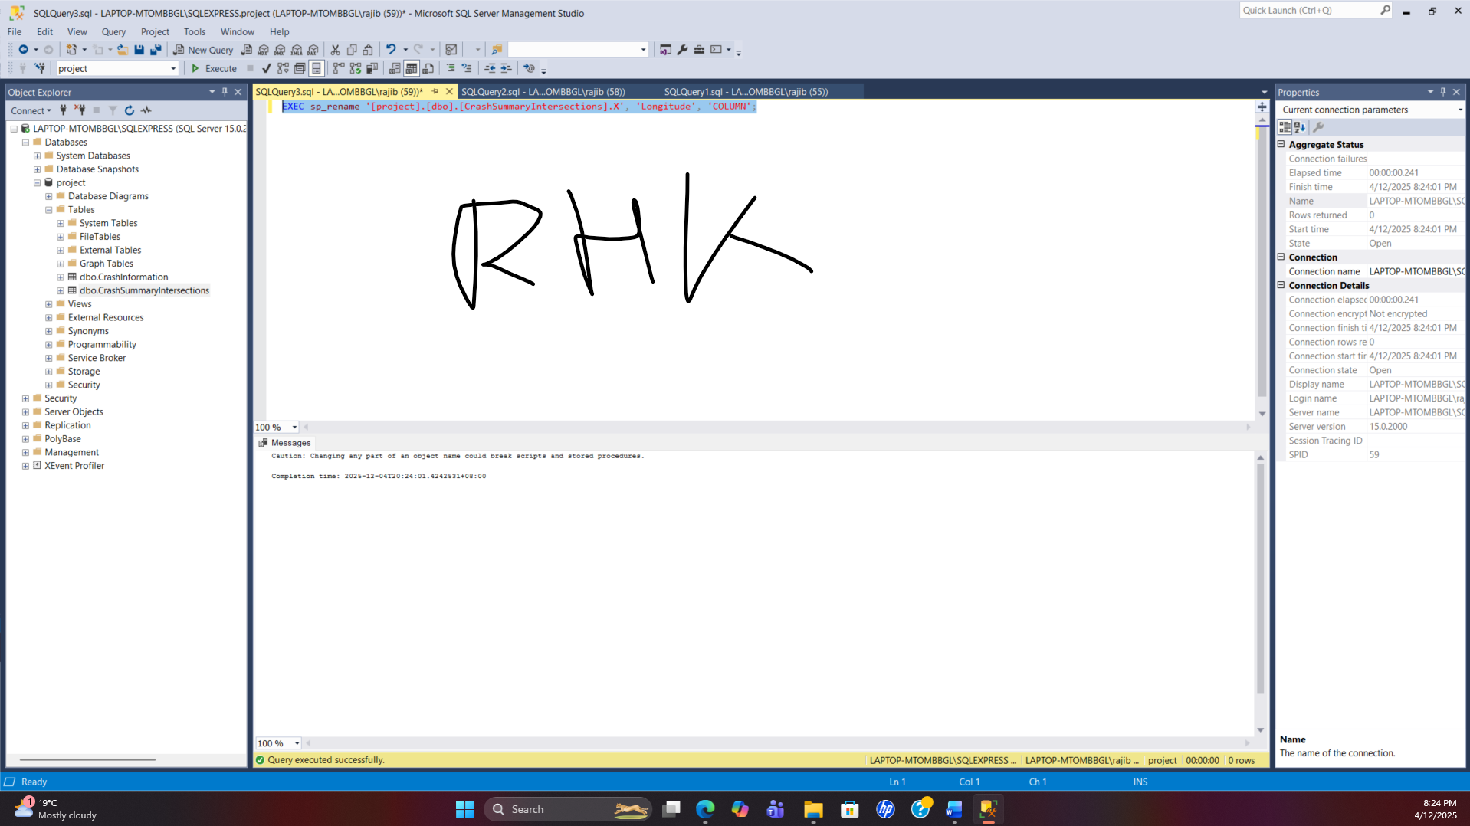

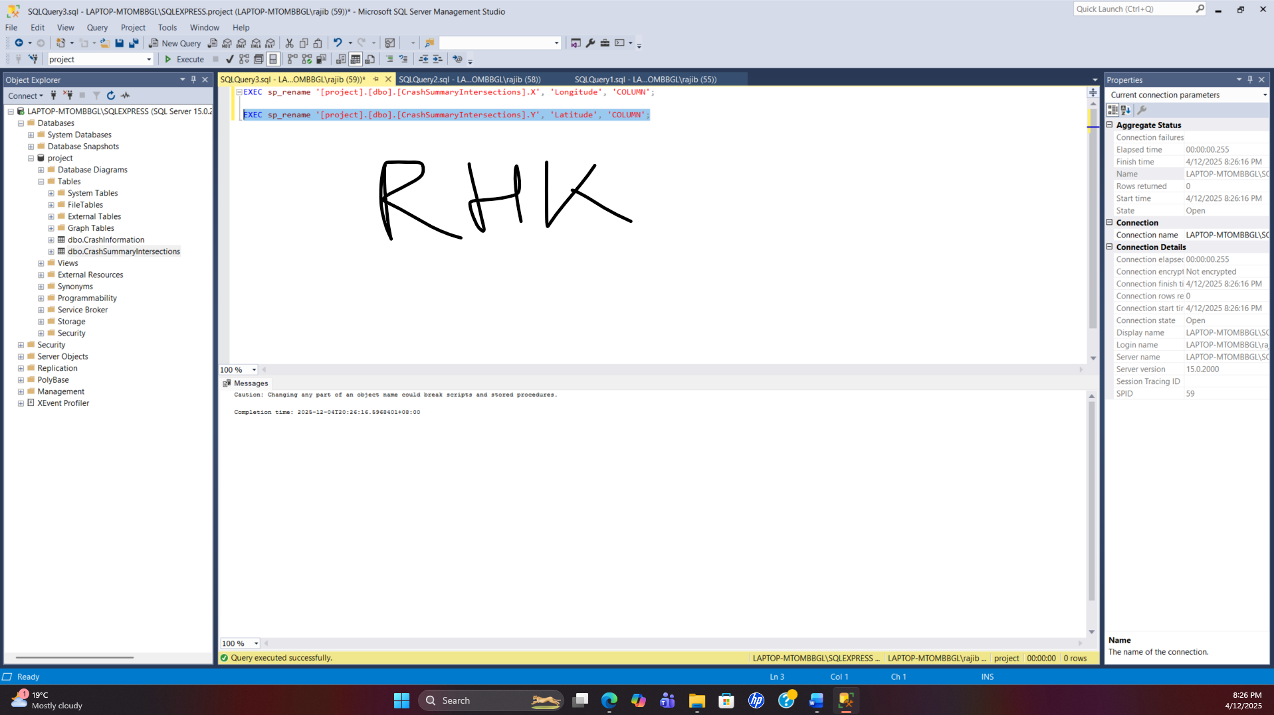

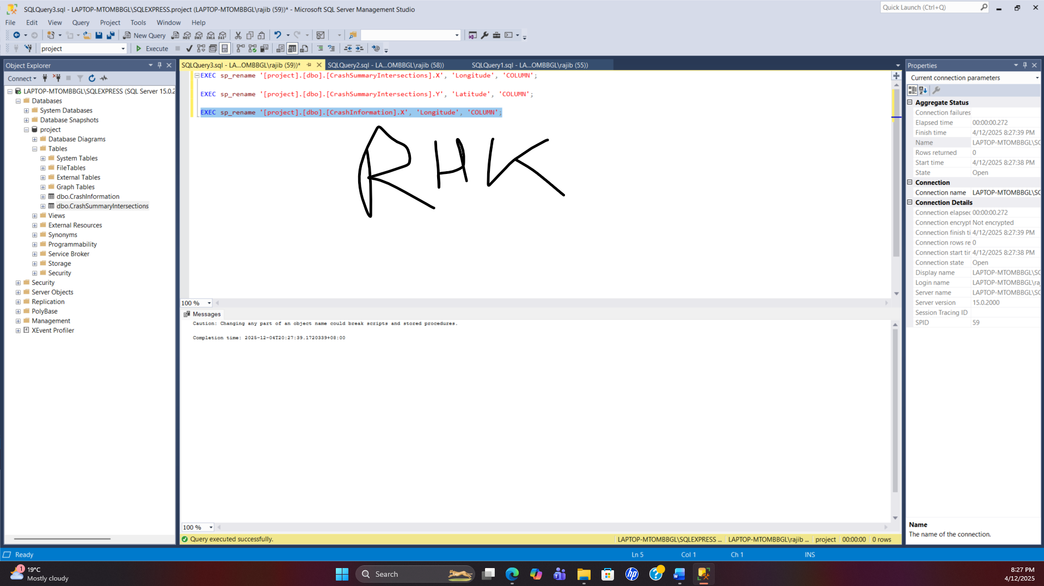

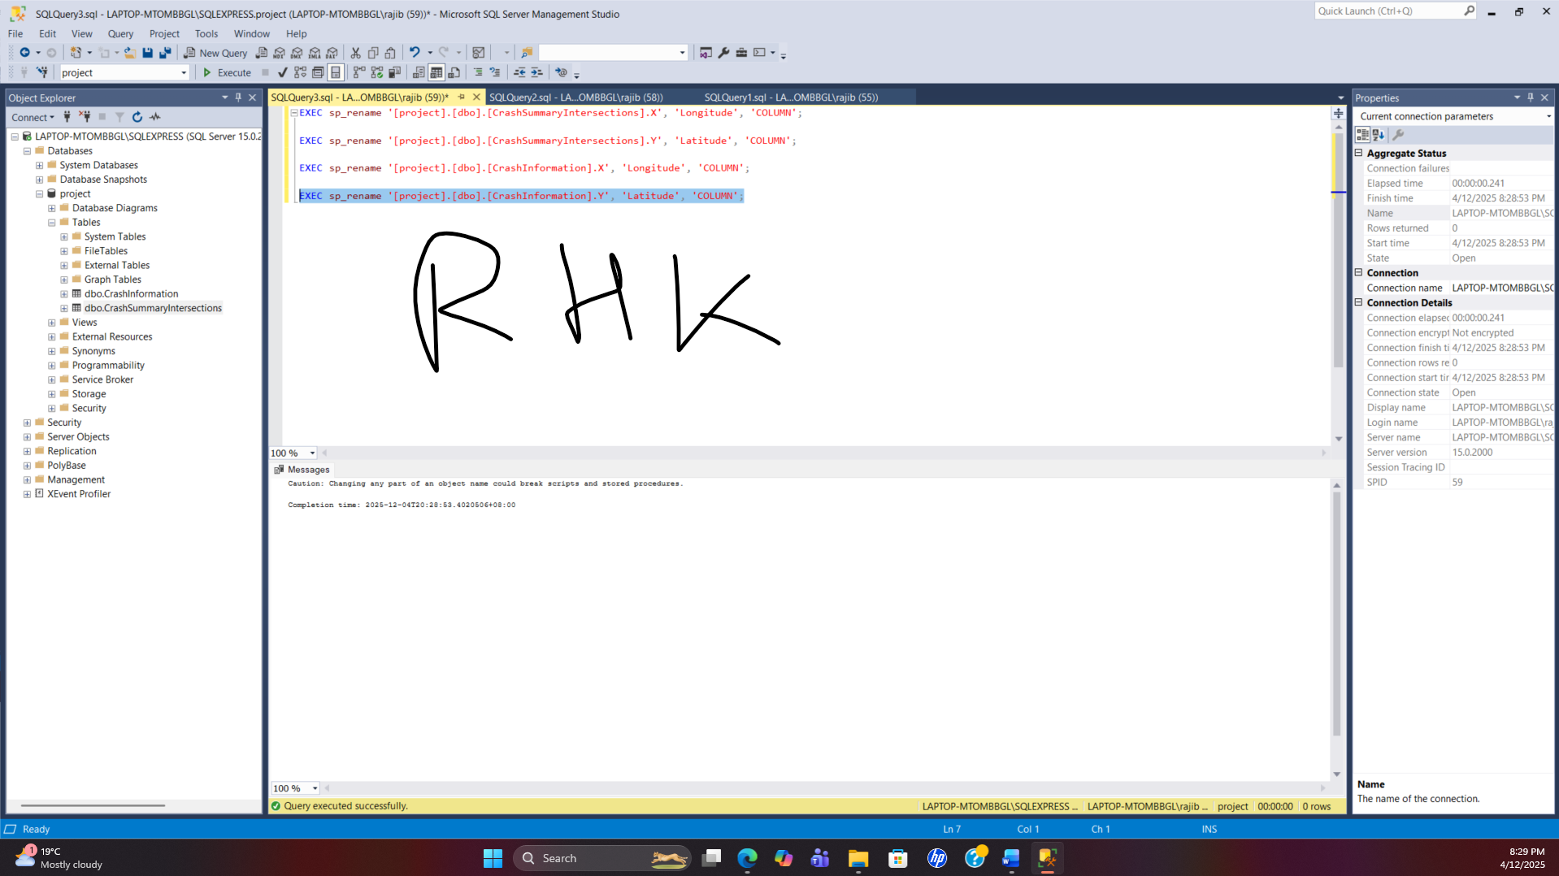

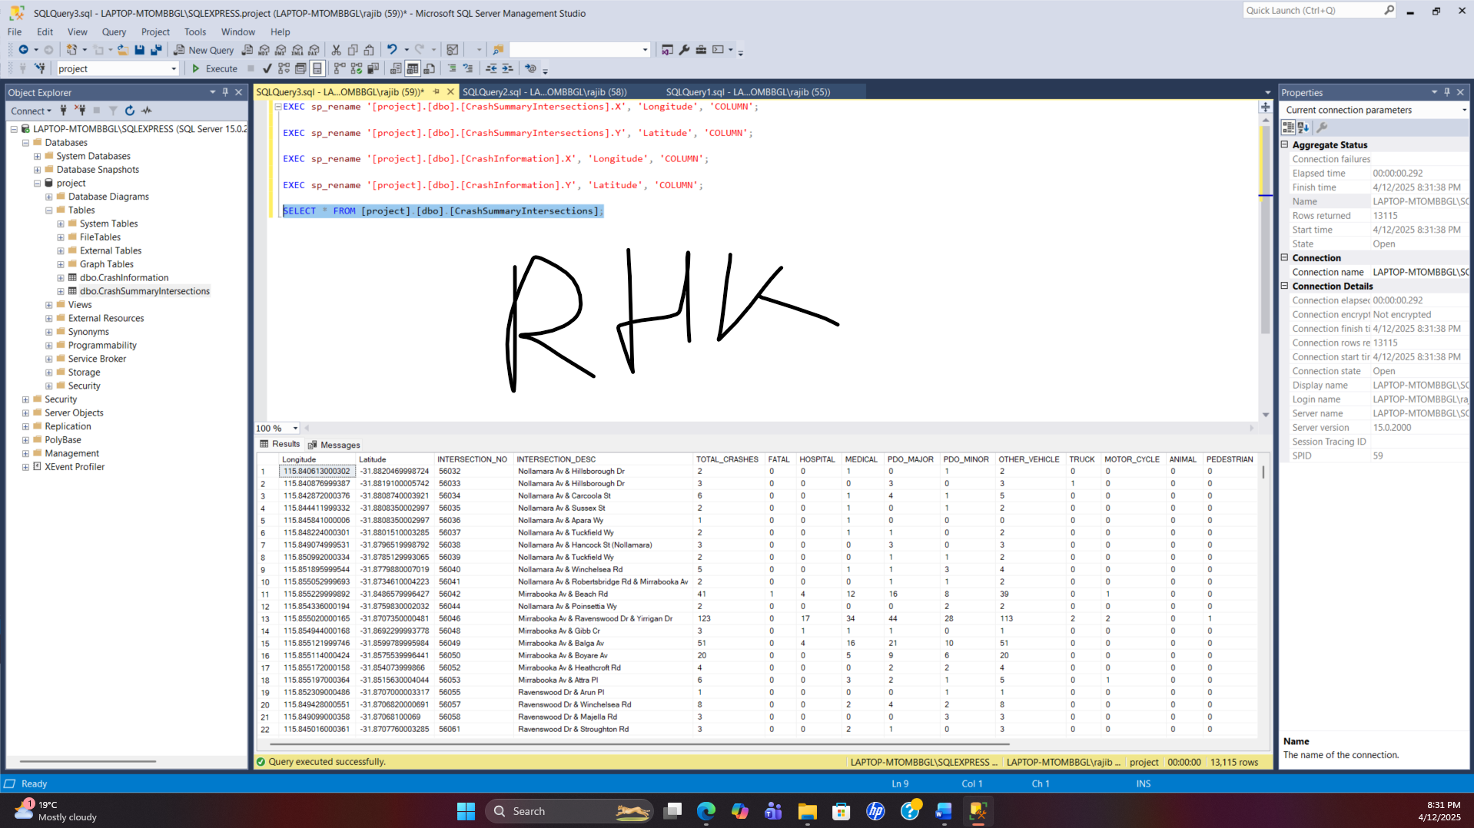

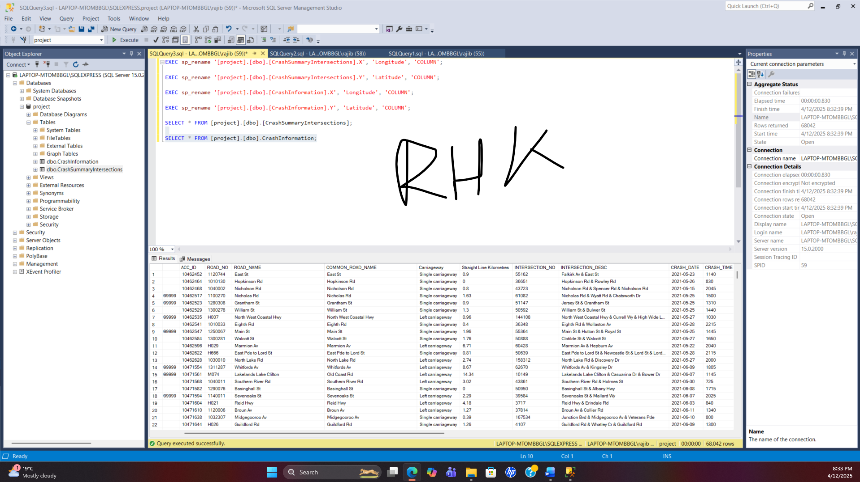

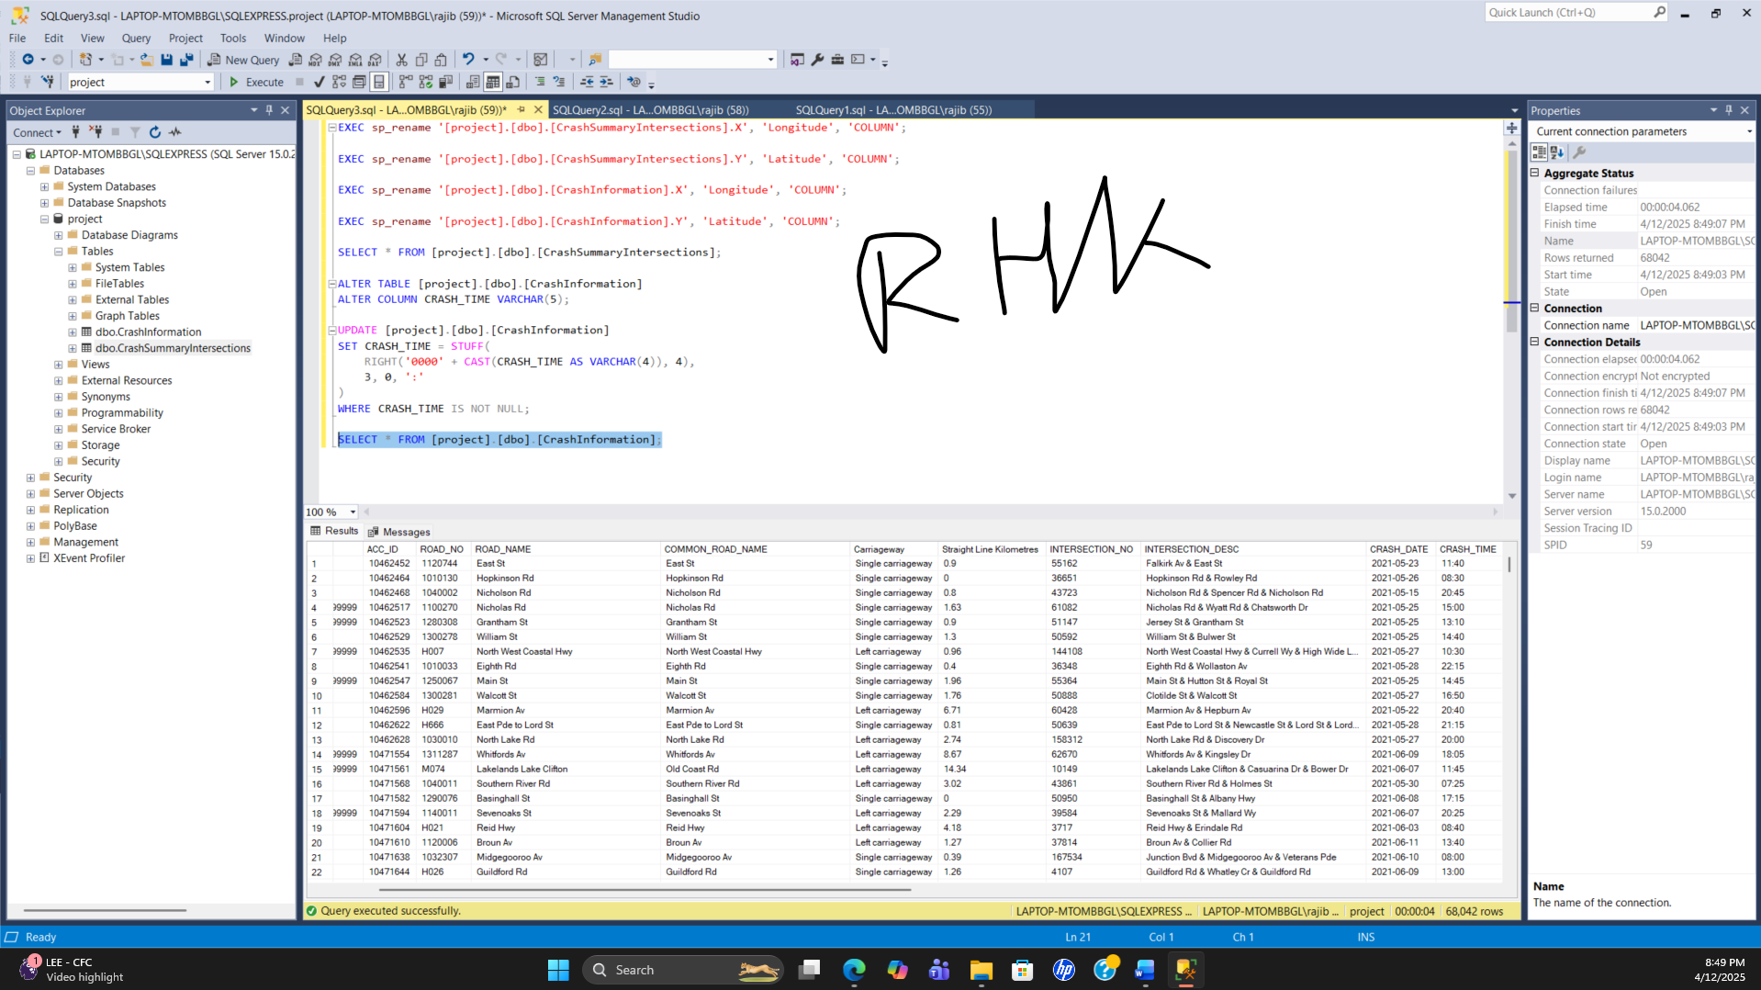

|  |  |  |  |  |  |
| --- | --- | --- | --- | --- | --- |
| **DATA VALIDATION AND CLEANING LOG** | | | | |  |
|  | Project name: | WA Crash Analysis | Data source | [Datasets - data.wa.gov.au](https://catalogue.data.wa.gov.au/dataset?theme=Transport) |  |
|  | Project description: | Crash Analysis of Intersections | Confidentiality | Public Data |  |
| **ID** | **Issue** | **Action steps** | **Status** | **Final resolution and notes** | **Resolved on** |
| 1 | Table Name | Changed the table name | Completed | CrashInformation, CrashSummaryIntersections |  |
| 2 | CWAY & SLK Column | Changed the column name | Completed | Carriageway & Straight Line Kilometres |  |
| 3 | CRASH_DATE | Data type changed from Date Time to Date | Completed | YYYY-MM-DD |  |
| 4 | Longitude & Latitudes | X & Y column renamed and additional columns deleted | Completed | Only one field in each table |  |
| 5 | CRASH_TIME | Time reformatted | Completed | HH:SS |  |
| 6 | Null values | Deleted null values from CrashInformation | Completed | where the Intersection No or Intersection Desc is null |  |
| 7 | Carriageway column | Value of S, L & R replaced | Completed | Single carriageway, Left Carriageway and Right carriageway |  |
| 8 | Duplicate | Checked duplicate values | Completed | No duplication |  |
| 9 |  |  |  |  |  |
| 10 |  |  |  |  |  |
| 11 |  |  |  |  |  |
| 12 |  |  |  |  |  |
| 13 |  |  |  |  |  |
| 14 |  |  |  |  |  |
| 15 |  |  |  |  |  |

1. **Were there any issues in the data set that you were unable to clean or resolve?**Compose a brief email to the project lead to inform them of the main issues that you encountered and what attempts you made to resolve them. What is the likely impact of these issues on the overall quality of the data analysis? If there were no issues, outline why you are confident of the data quality.

Dear X,  
I hope you are doing well. I would like to inform you that the data was already cleaned, analysed and interpreted by some government bodies. The date was already deidentified and anonymised.

I have also found a report available at [Crash Information (Last 5 Years) | Main Roads Open Data, Maps & Apps](https://portal-mainroads.opendata.arcgis.com/datasets/mainroads::crash-information-last-5-years/explore). Therefore, I had to do data cleaning to meet the purpose of this project and no issues were encountered to perform the required data cleaning actions. I have added the link and screenshot for your reference.  
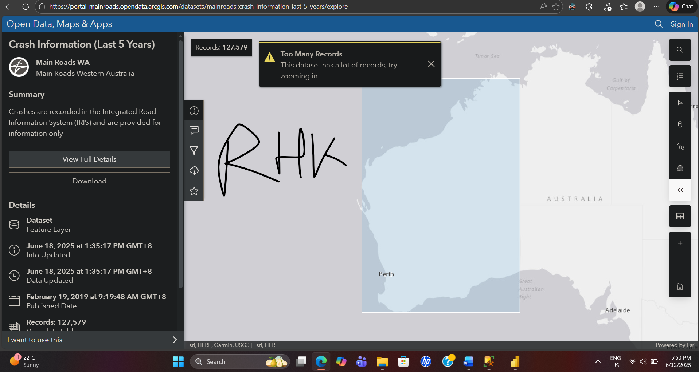

Thanks & regards  
Y

1. **Analyse the data.**   
   Include at least two visualisations. Associate them with the questions that you created in step 2.

<if applicable, use geodata presentation at least once>

<INSERT HERE OR INCLUDE YOUR Power BI data set

1. Based on previous crash data, find out the the number of serious, fatal and Property Damage Only carshes?  
   Ans: On Page one of our dashboard we have showed the Total No. of Crashes on WA Intersections for the last 5 years were 69.207 K and these crashes caused 3 K serious injuries. Among those crashes 151 was fatal. 31k crashed caused major property damage.  
   2. Based on the past crash tendencies, reflect on the year-by-year crashes for the WA intersections in the last five years?  
   After analysing the last 5 years crash data in the WA intersection we found that crash decreased in 2020 and 2022 but increased again on the following years.  
   3. Which intersections were mostly crash prone during the last five years?

The most interesting finding of this study is the ranking of the top ten intersections in WA with the highest number of crashes. Reid Hwy & Erindale RD is on top of the list with more than 250 crashes last 5 years whereas Reid Hwy & Altone Rd is at the bottom with nearly 150 crashes.

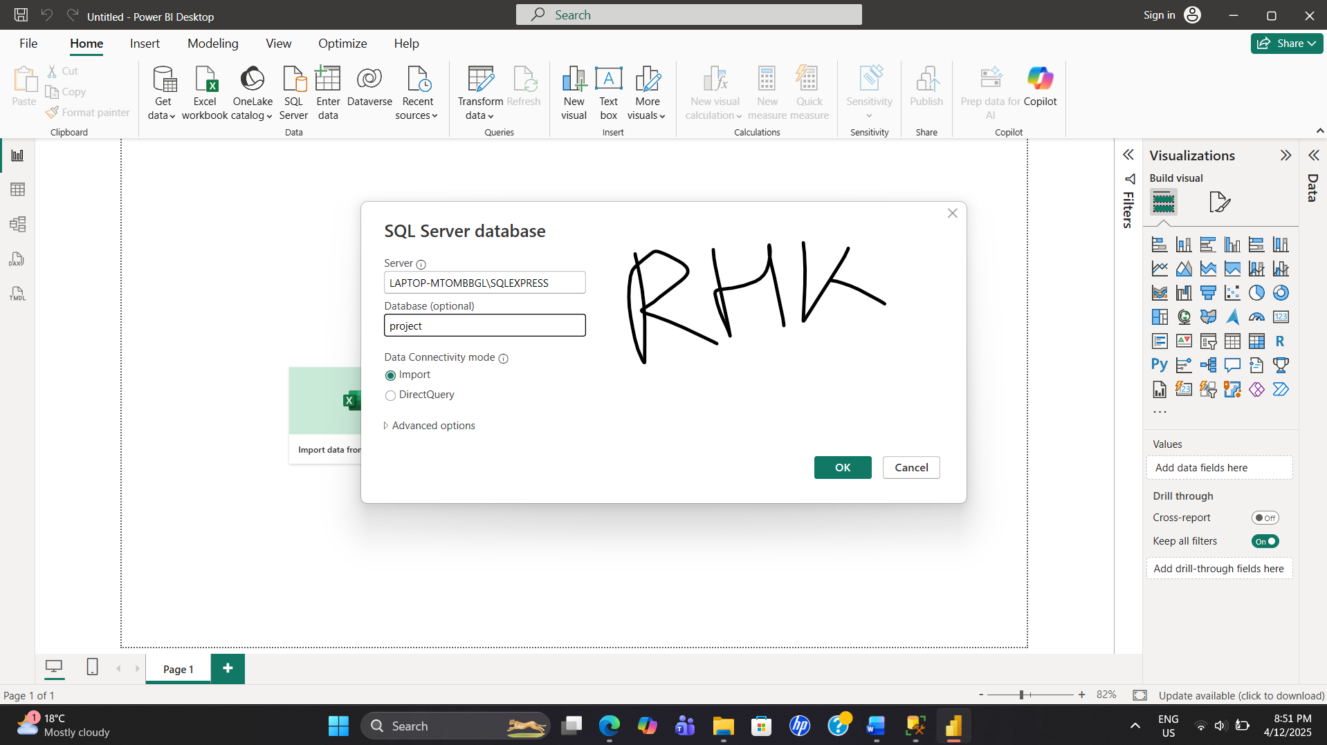

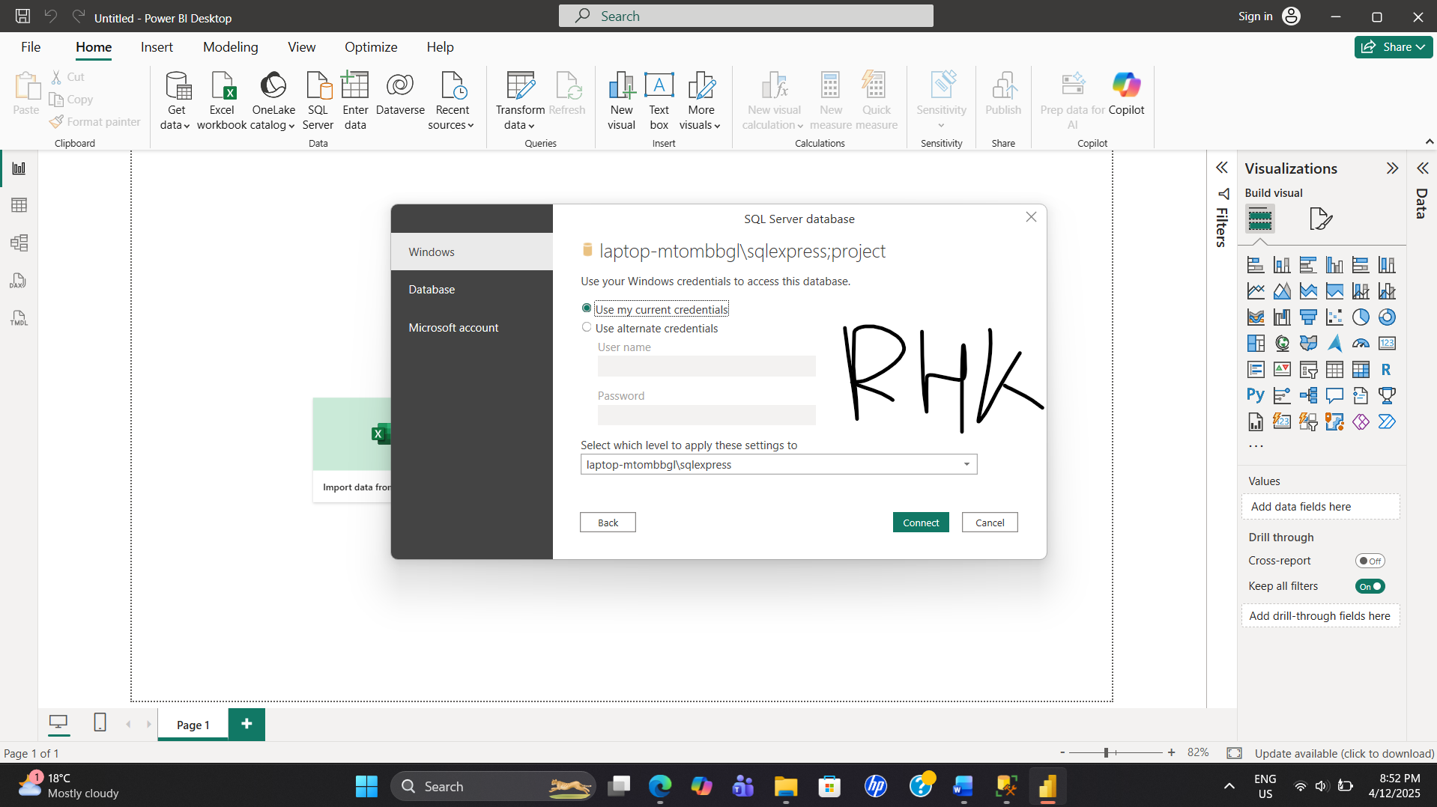

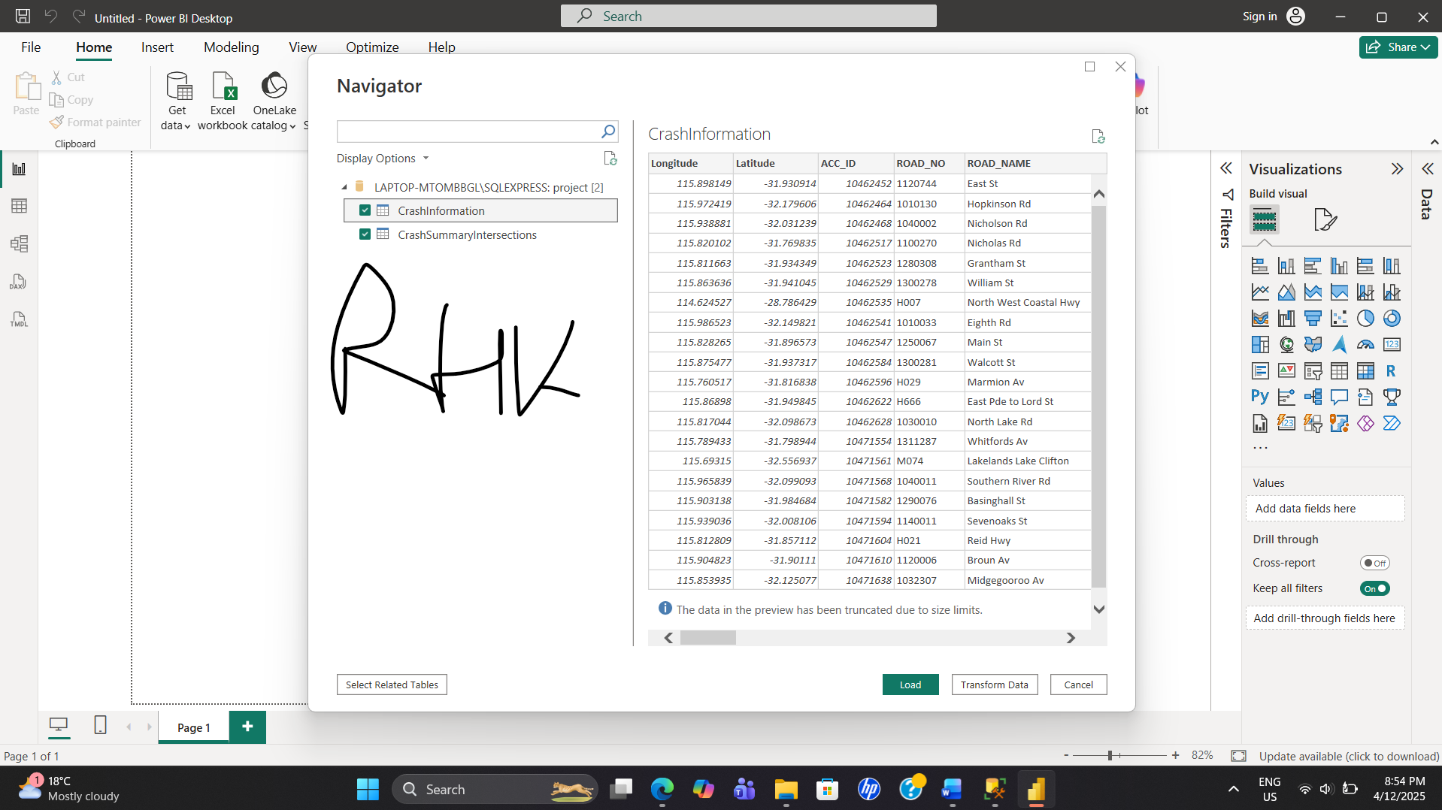

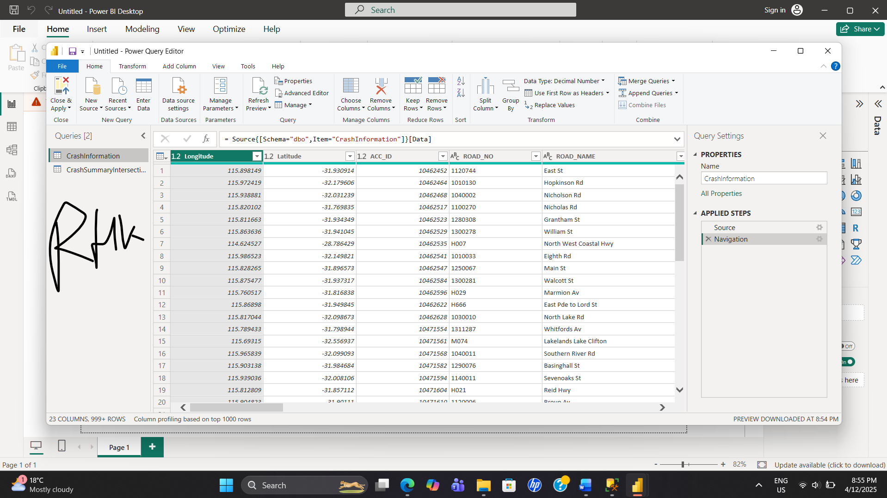

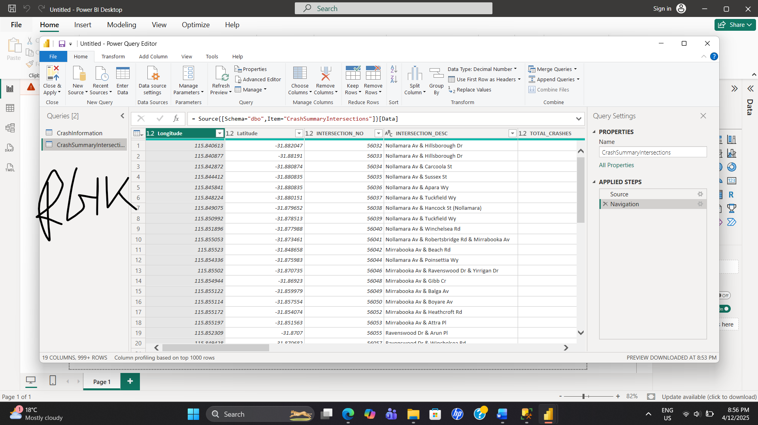

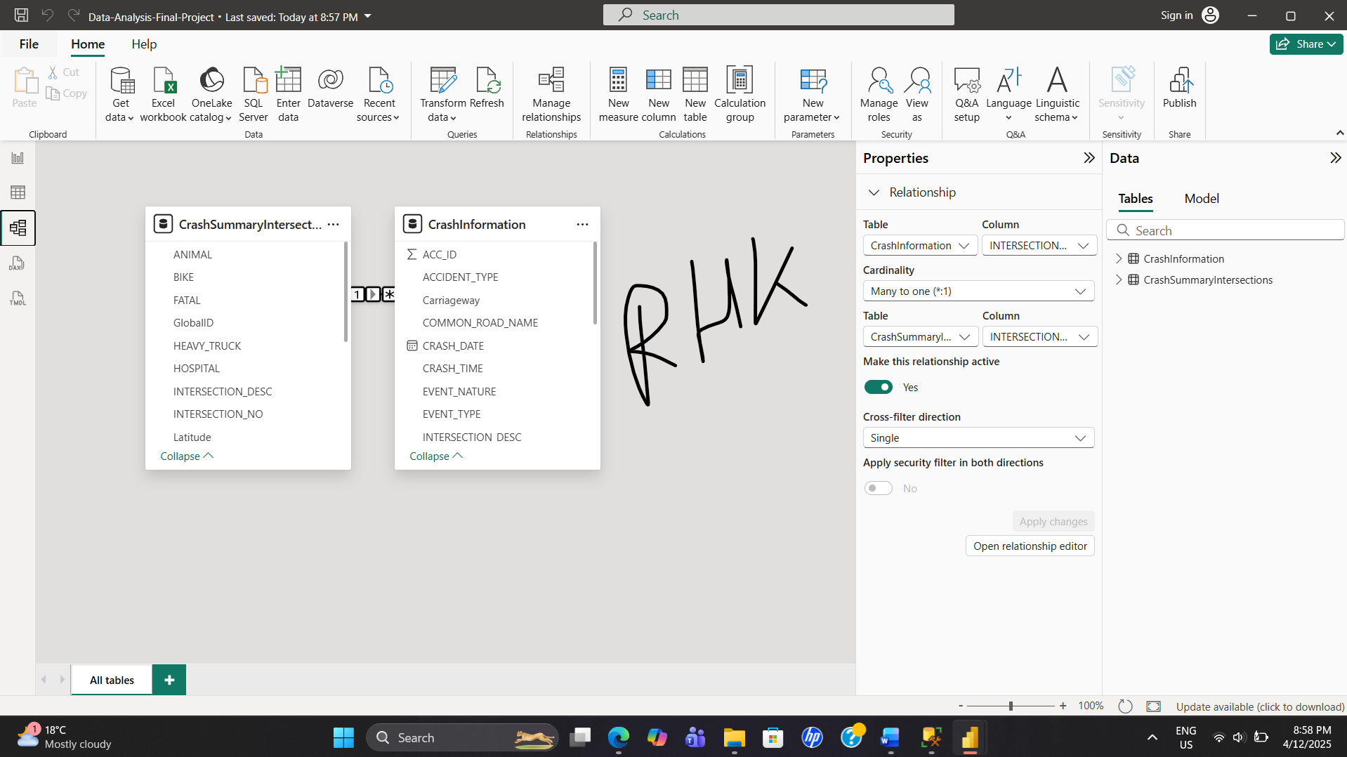  
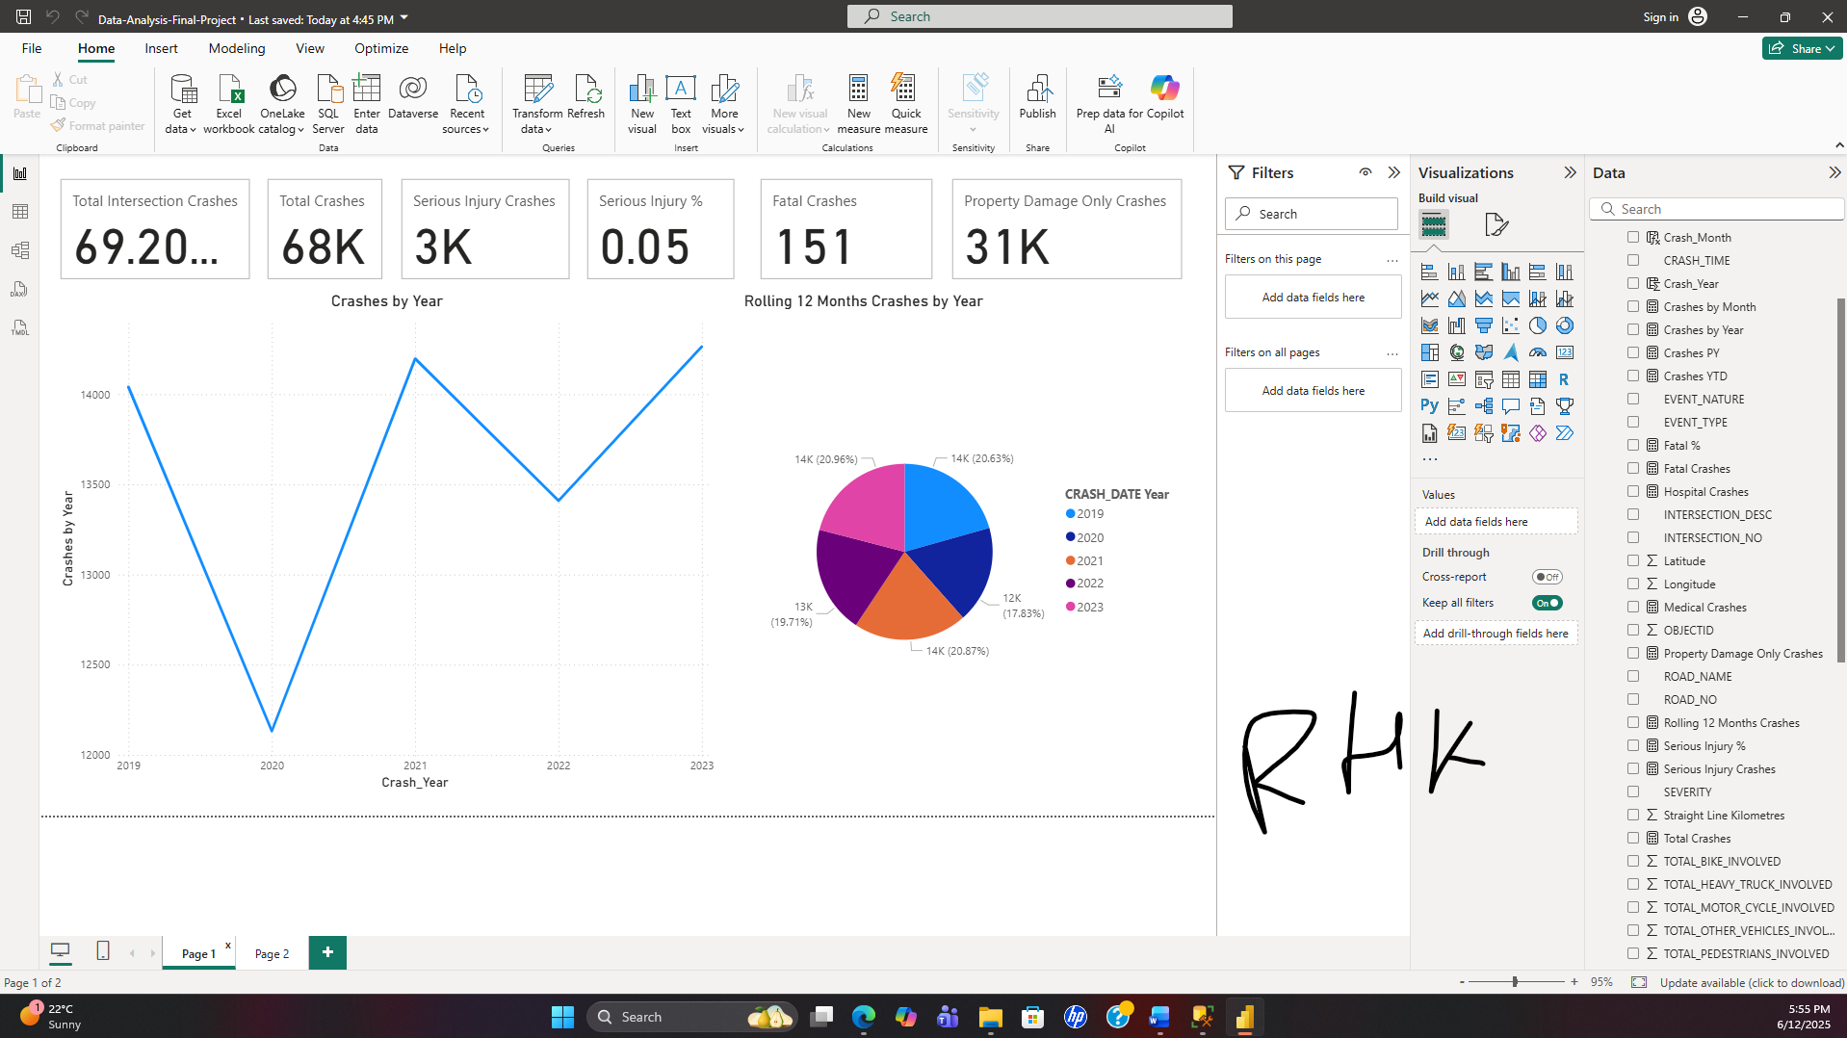

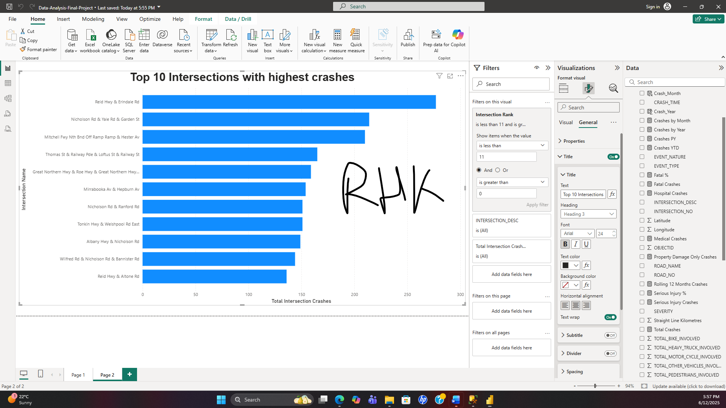

1. **Are there any questions you were unable to answer? Why/not?**

I could not answer question 4-12 due to time and resources constraints.

1. **Are there additional public data sets that could help with your analysis? What are they and how can they help?**

I think the datasets is quite large and completed enough to make a future projection and do an extensive analysis to find out other KPI’s.

# Appendix 1: How to gain business insights from the data

Google identifies the following problem types:

1. Making predictions
2. Categorising things
3. Spotting something unusual
4. Identifying themes
5. Discovering connections
6. Finding patterns

We can phrase questions that are specific, measurable, action oriented, and time bound (SMART) along each of the categories above.

Given your project data sets: _________________________________

Identify at least two SMART questions from each of the problem types.

1. Question: ________________________________________________
2. Question: ________________________________________________
3. Question: ________________________________________________
4. Question: ________________________________________________
5. Question: ________________________________________________
6. Question: ________________________________________________
7. Question: ________________________________________________
8. Question: ________________________________________________
9. Question: ________________________________________________
10. Question: ________________________________________________
11. Question: ________________________________________________
12. Question: ________________________________________________

Which three questions do you find the most interesting and/or relevant:

Q __ and Q __ and Q __

I found the following three questions most interesting.  
  
1. Does the time of day have an impact on the kinds of collisions that happen (e.g., fatigue-related at night)?   
  
2. Which temporal patterns—daily, weekly, or seasonal—can be seen in the frequency of crashes in Western Australia?   
  
3. Are there recurring geographic trends that indicate clusters of high-crash junctions or locations?

1. Try and describe an overarching theme for these questions:

To determine when and where collisions are most likely to occur, these questions jointly examine how time and location influence road-crash trends in Western Australia. The focus is on whether elements like fatigue, poor visibility, or peak traffic hours affect the kinds of collisions that occur by looking at the time of day. Examining daily, weekly, and seasonal patterns makes it easier to spot larger temporal cycles that could have an impact on traffic safety, including weekend travel patterns or spikes during the holidays. Lastly, geographic pattern analysis identifies high-risk crossings that frequently occur or areas where crashes tend to occur. When combined, these components seek to provide a thorough understanding of collision behaviour, enabling more intelligent transportation planning and focused preventative measures.